MINUTARIAN FROM DG MARK - WEEK OF APRIL 19, 2021
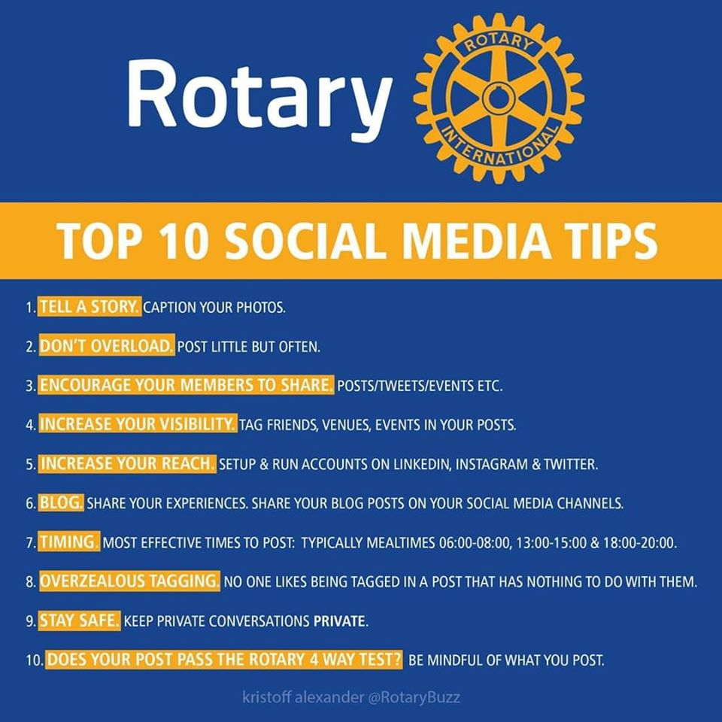
The biggest reason for using social media is engagement. Members who connect with their community provide vivid and recognizable value. You need to know what your audience wants to see and then incorporate that in your message.
Social Media can:
- attract potential members. They will see that you are having fun while doing good in your community and the world.
- attract community partners: potential sponsors will want to have their name on your projects.
- enhance members’ pride, keeping them engaged, inspired, and enthused.
- give family and friends a better understanding of Rotary and why you are a member.
- increase community awareness of Rotary and how we benefit our communities and the world.
How to improve your presence on Social Media:
- Post before future club meetings: speaker with compelling topic, graphics, pic, and bio.
- Post after each meeting with a brief summary or some bullet points. This also helps the speaker.
- If speaker approves, edit and stream your meeting live on Facebook, Vimeo, or YouTube.
- Be sure Rotary logo and theme are up to date. https://brandcenter.rotary.org/en-GB
- If you have Facebook and Instagram accounts, link them so your posts appear in both.
- Coordinate with your meeting/event planner(s) and use a calendar to plan posts for weeks in advance. Share doing posts to provide a variety of topics and viewpoints.
- Use People of Action images. Boring: people standing in a row. Interesting: people laughing, handing out food, cleaning a street, building a well, etc.
- Attribute photo credits and don’t “steal” graphics. Use professional or free graphics. Canva, Pexels, Rotary Branding Center.
- Use short videos; they get many more views and viewers retain their messages better.
- Vary themes: speakers, member profiles, club projects, contests, opportunities, polls, etc.
- In member profiles, share why they joined Rotary and what keeps them coming.
- Use the Rotary Branding Center to get ideas and guidelines.
- Urge members to use personal media, including LinkedIn for networking.
- Use hash tags and related media links: @RotaryD6890 @Rotaract6890 #WeAreRotary #PeopleofAction. etc.
- Include partners. It spreads readership and increases potential for sponsorships.
- Encourage readers to like your page and share posts.
- Use resources: https://vimeo.com/zone34publicimage; https://vimeo.com/showcase/myrotarystory; https://brandcenter.rotary.org/en-GB
Please be sure your club is active on social media....Facebook, Instagram, and even Linked In! The benefits are great for all of us. If you need help or have any questions, please reach out. Thanks!
Yours in Rotary Service-
DG Mark

