MINUTARIAN FROM DG MARK - WEEK OF APRIL 12, 2021
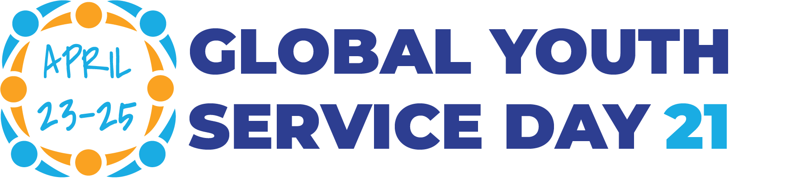
Global Youth Service Day (GYSD) is an annual celebration of young volunteers around the world. It is designed to encourage youth to participate in community service and service-learning and to honor those who have contributed to their communities through voluntary commitment.
Every year on Global Youth Service Day, youth organizations, schools and individuals around the world participate in thousands of projects. They focus on voluntary community service and range from learning sessions about current social and environmental challenges to clean-up actions, nursing home visits, and concerts. In past years, project have numbered over 5000 worldwide.
Global Youth Service Day was launched as National Youth Service Day in 1988. It is coordinated by Youth Service America, and most of the projects are based in the United States. However, a growing number of volunteers from other parts of the world take part in the activities each year. Project ideas can be found online at https://leadasap.ysa.org/ideas/ Some include cyber bullying, plastic pollution, art in your neighborhood, and gratitude for essential workers.
Rotarians are encouraged to work with your local Interact and Rotaract Clubs to create meaningful projects for your community. Share your ideas and let us see your projects in action by posting videos and images on Facebook. Let's inspire our youth and help lead them towards being #PeopleofAction!
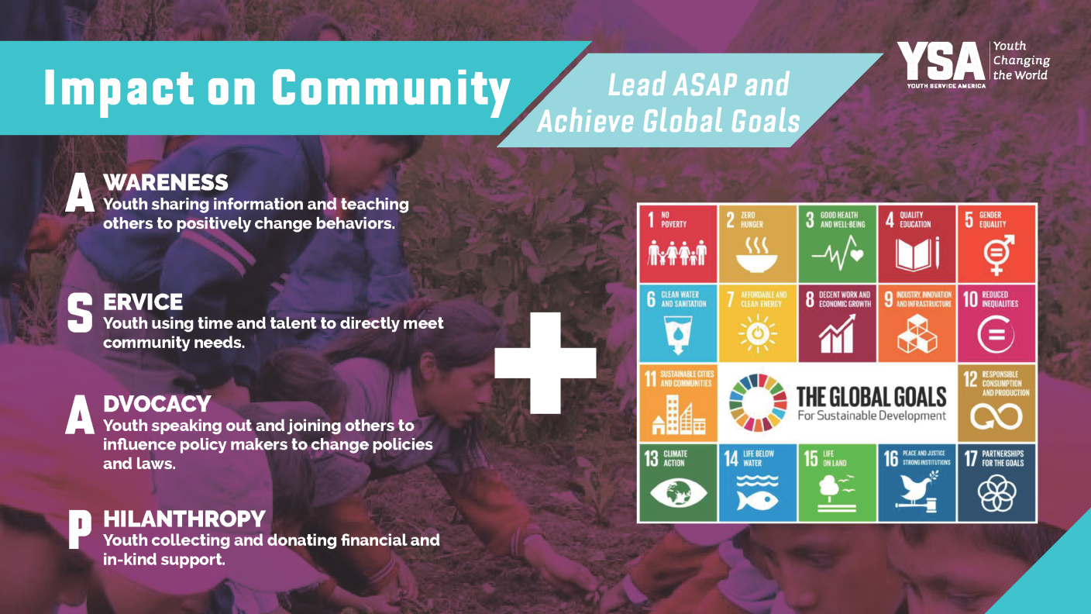
Yours in Rotary Service-
DG Mark

