MINUTARIAN from DG MARK For meetings the Week of March 29, 2021
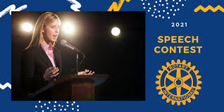
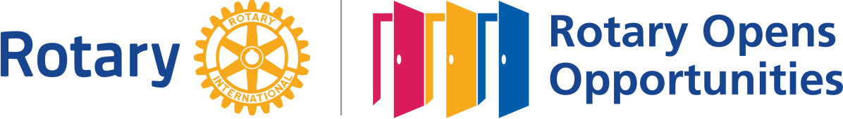

Rotary Speech Contest for 2021
Many vocations require skills in good communication, the ability to research and deliver information and ideas confidently. The Rotary Speech Contest provides a platform to build those skills. The program promotes public speaking in a competition for high school students in District 6890. Benefits to participating students include exposure to the ideals and ethical values of Rotary, proficiency in the art of public speaking and confidence and self-esteem gained from presenting to large audiences.

COVID can't keep us from making a positive impact in the lives of future Rotarians! This year's Rotary speech contest chairperson is Sarah Breed from The Lakeland Rotary Club. Sarah is a prior winner of the District Speech Contest and we are fortunate to have her leading this project for the second year. The theme this year is "Rotary Opens Opportunities".

The contest is open to all high school students in District 6890. Each contestant is asked to speak on the same theme: Rotary Opens Opportunities. A panel of judges evaluates the contestants on delivery, originality, and content.
The speech must be between five and seven minutes and will be judged on the following elements: content (40 points), organization (30 points), and delivery (30 points). Notes are allowed but discouraged during the Club Level competition. Notes are not permitted during the Group Level and District Finals.
There are three rounds of competition. The first round is at the Club Level completed February. The winner proceeds to the Group Level competition, competing against four or five other Club Level winners. This phase will be completed no later than March 26, 2021. The winner of the Group Level proceeds to District Finals that will be conducted the evening of April 12, 2021.
Typically, first prize at the Club Level is $100. The winner of the Group Level usually receives $250. The District Finals winner will receive $1,000. There are lower monetary awards to the 2nd and 3rd place winners as well.

Please join us on April 12th for the exciting finish to this year's District 6890 Rotary Speech Contest!

Yours in Rotary - DG Mark

