MINUTARIAN from DG MARK For meetings the Week of March 22, 2021
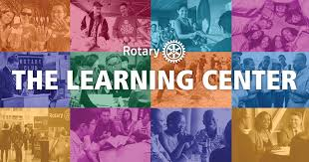

Enhance your leadership skills in the Rotary Learning Center
Professional development is right at your fingertips with the Rotary Learning Center, which offers members a range of interactive courses on navigating Rotary's online tools and developing leadership skills to prepare for new Rotary roles.
Anyone with a My Rotary account can take free courses in the Learning Center. Among the many courses available are How to Run a Webinar, How to Develop and Deliver a Speech, Leadership Basics and Leading a Team, Engaging Members, Public Image, and so much more.
Get started by finding the Learning Center under the LEARNING & REFERENCE tab on Rotary.org. If you are already registered on the site, you will have a profile. If not, it's easy to create an account.
The center's catalog allows you to browse a list of subjects or see a complete rundown of all the courses offered. Course material is provided in a variety of formats, including PDF and Word documents, interactive e-learning modules, and videos. Only some e-learning modules have audio, but all of them enable you to decide when to go on to the next screen.
A bar at the top of the screen marks your progress through each course. And a snapshot of all the courses you have registered for is available with the COURSE HISTORY tab, which also enables you to print a certificate once you have completed all requirements.
Rotary's Learning Center is a powerful and underutilized resource. Many Rotarians don't realize the extent of what is there and what's useful for them. Please go explore and let's work to change that! Learning Center
Yours in Rotary -
DG Mark

