MINUTARIAN FOR WEEK OF FEBRUARY 8, 2021
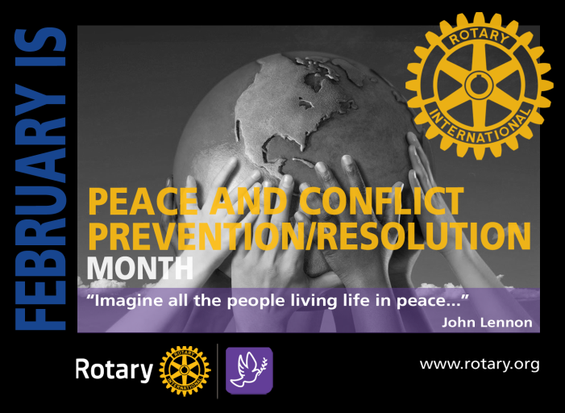
During February, Rotary Peace and Conflict Prevention/Resolution Month, we’re celebrating our commitment to build peace and mitigate conflict. Rotarians train adults and young leaders to prevent and mediate conflict, and aid refugees who have fled dangerous areas. Of the 60 million people displaced by armed conflict or persecution, 90% are civilians. Half of those civilians are children. That’s millions of reasons why Rotary is so engaged in service projects, fellowships and other Rotary-sponsored campaigns in pursuit of peace in our world.
We train adults and young leaders to prevent and mediate conflict. We aid refugees who have fled dangerous areas. Rotarians also address the underlying structural causes of conflict by relieving millions of people suffering from poverty, inequality, ethnic tensions, lack of access to education and unequal distribution of resources.

In a program to achieve worldwide peace, up to 130 Rotary Peace Fellows are selected to attend Rotary Peace Centers. Fifty participate in master's degree programs and 80 for certificate studies. Rotary Peace Fellows study subjects related to the root causes of conflict and explore innovative solutions that address real-world needs.
These opportunities are designed for leaders with work experience who want to dedicate themselves to become catalysts for peace through community development. The fellowships cover tuition and fees, room and board, round-trip transportation, and all internship and field-study expenses.
This program started in 2002, and since that time, more than 1300 fellows have worked in 115 countries. They are leaders in governments, NGOs, the military, education, law enforcement, and international organizations like the United Nations and the World Bank. The application process for RY 2022-2023 opens in February.
How can we help? RI suggests three ways:
- Donate. Rotary Peace Centers are possible through the generous support of donors.
- Promote. Advance peace and development around the world by promoting the Rotary Peace Fellowship program. Linda Devine is our district’s contact person, so if you know someone who may be interested, connect them to Linda. ldevine@ut.edu 813.253.6203
Do you have a Peace Fellow candidate in your community? For more information:
https://www.rotary.org/en/our-programs/peace-fellowships

Yours in Rotary -
DG Mark

