MINUTARIAN from DG MARK For meetings the Week of February 22, 2021
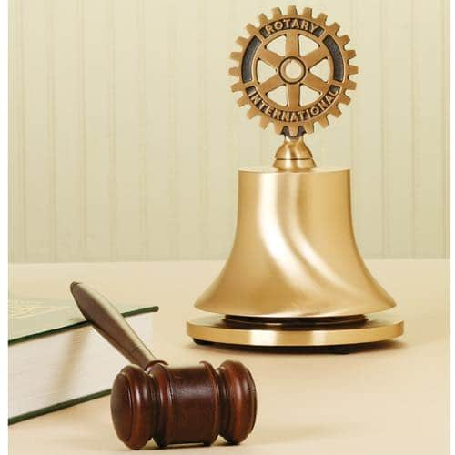

Did you ever wonder how the tradition of the Rotary Bell began?
In 1922, U.S. Rotarians organized an attendance contest to see which club could increase their attendance at meetings the most. The challenge was that the losing clubs would join in giving the winning club a prize. The Rotary Club of New York City was declared the winner and they were awarded as a prize, a bell from a popular patrol boat, which was placed on a block of wood that came from HMS “Victory,” Admiral Nelson’s vessel at the battle of Trafalgar.
Since then, the bell used in Rotary meetings started to represent, as on the ships, order, discipline and the time to guide us through the weekly hour and a half meetings. The bell informs us with its sound the beginning of the meeting at which time people present should stand in order to salute the US and Rotary flags. The sounding of the bell concludes meetings and is also rung at somber times.
So, now you know. Pass it on. Stand tall and be proud of our tradition. Rotary Opens Opportunities! Help grow Rotary! Bring a friend to a meeting and share this tradition along with the fellowship and service that keeps us coming back.
Yours in Rotary-
DG Mark

