MINUTARIAN FOR WEEK OF DECEMBER 7, 2020
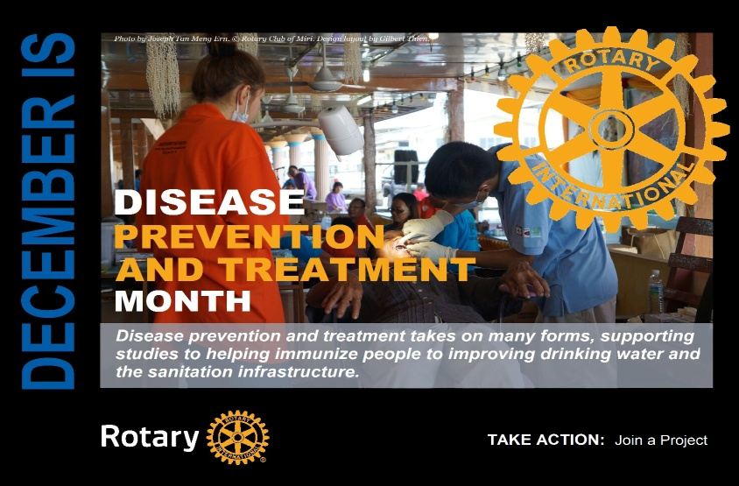
FIGHTING DISEASES IS ONE OF ROTARY'S MAIN AREAS OF FOCUS
We believe good health care is everyone's right. Yet 400 million people in the world can't afford or don't have access to basic health care. We educate and equip communities to stop the spread of life-threatening diseases. Rotary members have hundreds of health projects underway around the world at any given time.
Disease results in misery, pain, and poverty for millions of people worldwide. That's why treating and preventing disease is so important to us. We lead efforts both large and small. We set up temporary clinics, blood donation centers, and training facilities in underserved communities struggling with outbreaks and health care access. We design and build infrastructure that allows doctors, patients, and governments to work together. Prevention is important, which is why we also focus on health education and bringing people routine hearing, vision, and dental care.
Rotary's top priority is the eradication of polio, but members also take on far greater responsibilities to fight disease. They set up health camps and training facilities in undeveloped countries and in communities struggling with HIV/AIDS and malaria.
Disease prevention and treatment takes on many forms, from supporting studies to helping immunize people to improving drinking water and the sanitation infrastructure. The world relies on Rotary to tackle these global challenges, and to set an example for others to follow.
What is your club doing to help prevent and treat disease? Share at #RotaryDistrict6890
Yours in Rotary - DG Mark

