MINUTARIAN FROM DG MARK Week of October 26, 2020
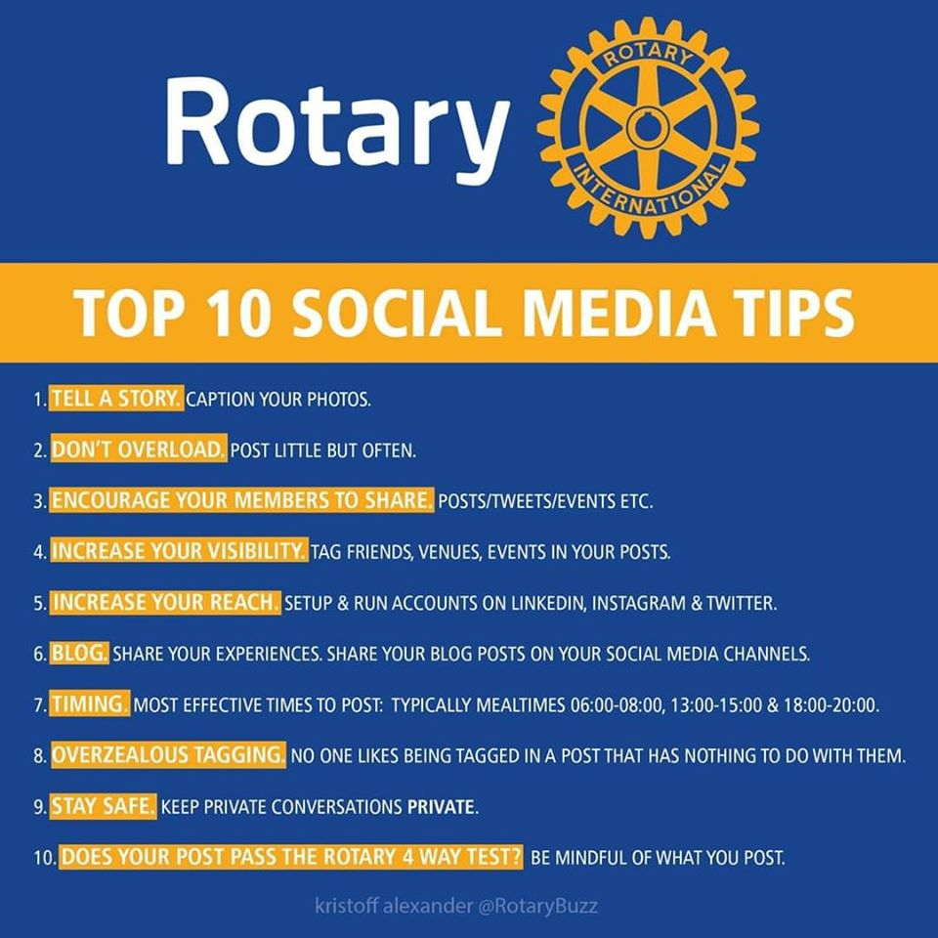

Rotary Public Image
Does your club have someone or a team who are making the world know who you are and the good you are accomplishing? Well, okay, maybe not the whole world, but what about your district and your community? Making people aware of your activities, meetings, programs, events, and projects gets people interested in joining you or at least learning more about what you are doing and what Rotary is all about. Those are great benefits! This isn’t about just tooting your own horn or seeing pictures of each other online. We are talking about opportunities for increasing membership and sharing ideas.
Starting is easy. Use Facebook or Instagram and post information on when your next meeting, social, or fundraiser is. Let people know they are welcome to join you. Use the # sign as a hashtag to share your posts with #RotaryDistrict6890, #endpolio, or #PeopleofAction, etc. You can schedule posts to be published on specific days and at specific times too. So you can have a calendar to plan ahead for what you want to be posted and when. This can be a real time saver!
Aside from pictures, be sure to use short videos. Did you know that social media posts with video have 48% more views? They also make your post really come alive. Would you rather look at a picture of people standing in a row smiling at the camera or see people working together on a project and having fun? Which one says….”I want to be part of that!”?
If you need some help getting started, please reach out to me and be sure to ‘Like’ our #RotaryDistrict6890 Facebook Page!
Yours in Rotary – DG Mark

