MINUTARIAN FOR WEEK OF JANUARY 25, 2021
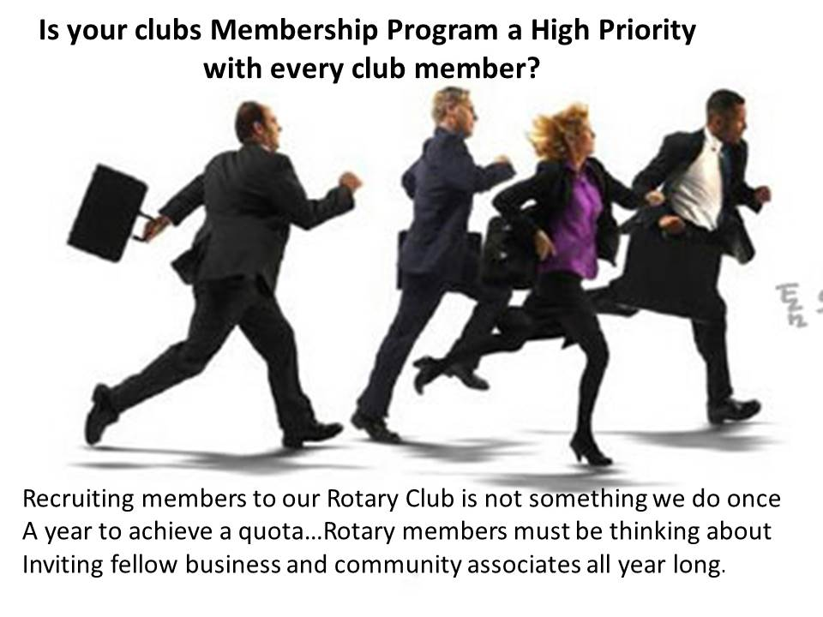
Becoming a Rotary member connects you with a diverse group of professionals who share your drive to give back. Through regular meetings and events, we discuss community needs and develop creative ways to meet them. We connect with other leaders who are changing the world. We expand our leadership and professional skills and we catch up with good friends and meet new ones. Our motto is "Service Above Self" and our vision statement truly tells of our impact:
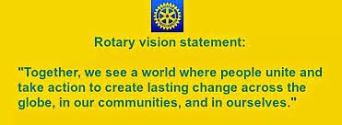
Each of us has our own reasons for being a Rotarian....not just in Rotary....we have had some sort of an 'aha' moment that made us feel more connected and driven to remain a Rotarian. Those are the Rotary stories we need to share with our friends and colleagues at work, with the book store seller, the restaurant manager, and the neighbor up the street. Invite them to a meeting or have a small, safely distant social get together to introduce them to Rotary or meet them for coffee and share your passion for Rotary with them one on one.
I urge you to go to https://my.rotary.org/en/learning-reference and explore the learning center. There is a new member section as well as sections to learn by role, or topic, policies, procedures, webinars, and more. More information on joining Rotary is at: https://www.rotary.org/en/get-involved/join
Questions - reach out to me at markscolnickdistrict6890@gmail.com or contact our district membership chair Ed Odom at: edodom01@gmail.com
Yours in Rotary- DG Mark

