Installing the Zoom App
If you are working from a desktop, just click on the meeting invitation link and Zoom will download for you. If you want to do it yourself, or to connect from other devices, use the quick links below.
For Apple devices- https://apps.apple.com/us/app/id546505307
For Android devices- https://play.google.com/store/apps/details?id=us.zoom.videomeetings
For desktops (Zoom Client for Meetings)- https://zoom.us/download
Scheduling extension for Chrome browsers (hosts only)- https://chrome.google.com/webstore/detail/zoom-scheduler/kgjfgplpablkjnlkjmjdecgdpfankdle?hl=en&gl=US&authuser=1
All other environments - https://zoom.us/download
Tip: Anyone can download the Zoom App. You will not be prompted for admin passwords or require any special access.
Once downloaded, follow the steps below.
Click “Sign In” on the Zoom Client and enter your password if one was provided.
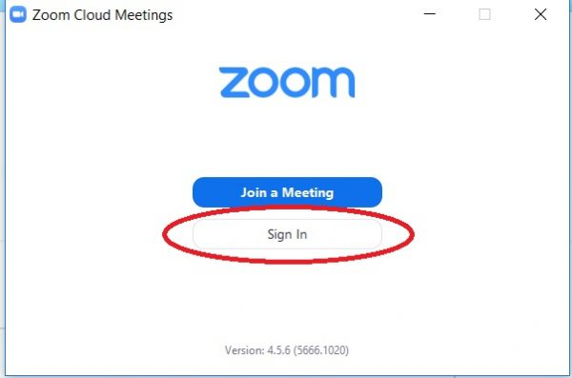
It’s okay if you don’t have an account. Just sign in using Google or Facebook when prompted and respond “yes” when asked if it’s okay to launch Zoom.
You should now have the client looking like this:
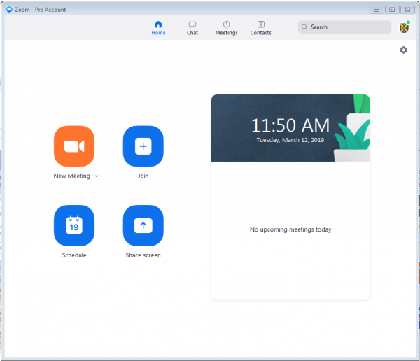
From here you can Join Meetings, Schedule Meetings and Chat with other Rotarians. If you’ve used the JOIN link as provided in the email invitation you may have received, just click it and it will take you straight to the meeting without any further hassle.

-adapted from University of Otago’s web site https://blogs.otago.ac.nz/zoom/how-to-install-and-sign-in-to-the-zoom-app/

