Hosting a Zoom Meeting
If you’d like to set up your own personal or club Zoom Meeting Room, then please follow the 4-step guide with short instructional videos at the end of each section.

Step 1 – Sign in to your Zoom Account

Download the “Zoom Client for Meetings” at https://zoom.us/download

Step 2 – Inviting someone to your Zoom meeting
On your Profile page you will see your Personal Meeting ID
Copy the link and send this to whomever you wish to meet with (you can do this via email, instant messaging, text or even just get them to type the link into their browser if you are talking with them on the phone)
Once they receive the link, they can then simply click on it to join your meeting at an agreed time. You can do the same at that time.

Step 3 – Installing Zoom
The first time you or your invitees click on your Personal Zoom link, Zoom will download.
Once downloaded, click the “Zoom_launcher” file to run and automatically install Zoom.
See below for examples of how this will look in Chrome & Firefox browsers:
Chrome:
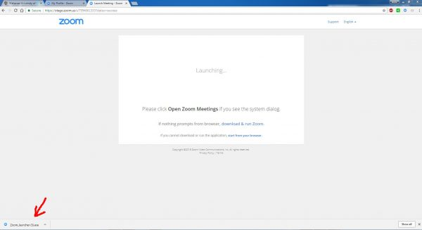
Firefox:
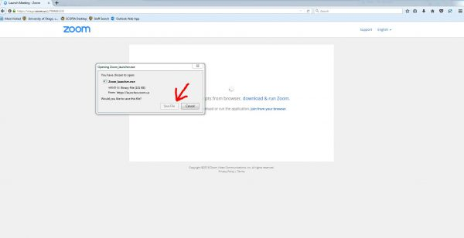
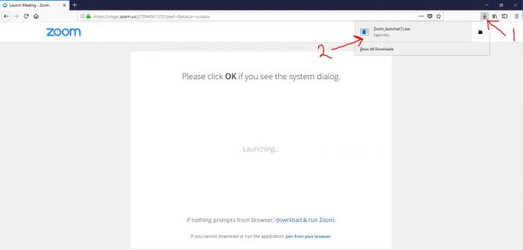
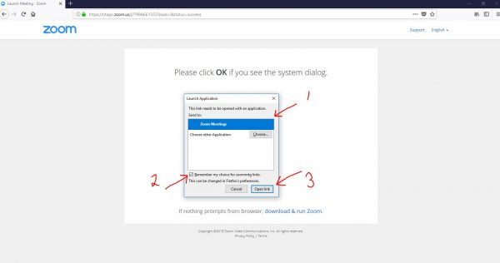

Step 4 - Joining audio by computer or phone
The first time you join a Zoom meeting, you will be prompted to select how you wish to connect your audio. In almost all case you will select “Join Audio Conference by Computer”, this will use the default mic & speakers on your computer. Don’t forget to tick the “Automatically join audio by computer when joining a meeting” option in the bottom left corner first so you can avoid being prompted in future meetings.
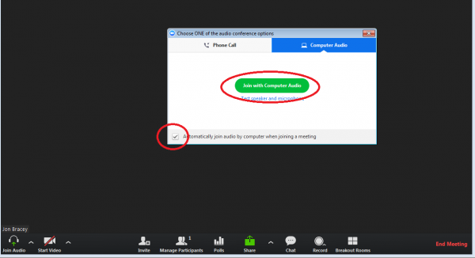
Alternatively, if you (or one of your invitees) prefers to join via the phone, then they can select the “Phone Call” tab.
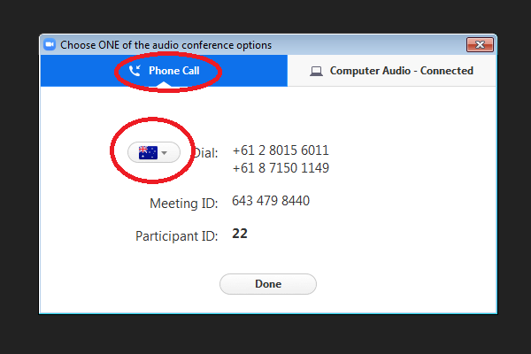
They can then choose the best phone number for the country they are calling in from by using the drop down list of flags.
If they are in the US and select that number it will be treated as a normal national toll call rather than an international call, which is especially handy for connecting with friends or family members overseas who do not have access to good quality internet or who are not comfortable with using a computer or mobile device.
In the latter situation, the person can even simply dial directly into your Zoom meeting on the phone, without needing to run Zoom on a computer first. Just find the best “local” phone number for them here and send it with your Zoom Personal Meeting ID found on your Zoom profile page (this is the 10 digit number). They will be prompted to enter this meeting ID when they call in.
-adapted from University of Otago’s web site https://blogs.otago.ac.nz/zoom/getting-started-with-a-zoom-account-for-students/

