Setting a Virtual Background
Open the Zoom dialog box (click once on your Zoom icon to open this box, assuming you have downloaded it to your computer).
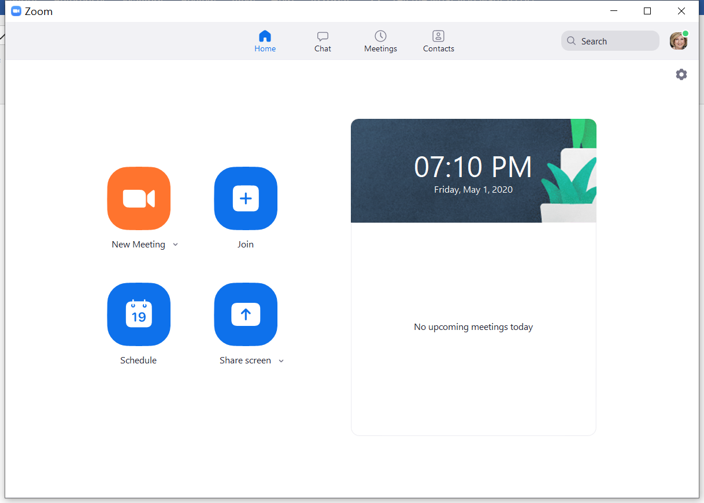
Click on the settings gear just underneath your profile picture. This will open the settings dialog box:
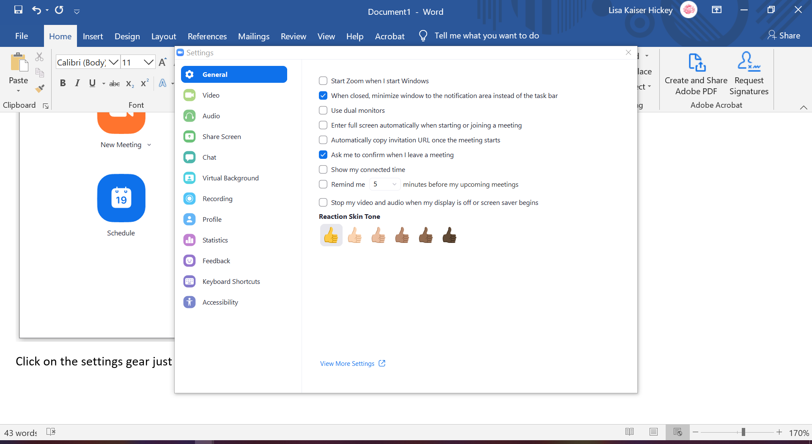
Click on Virtual Background from the left sidebar menu:
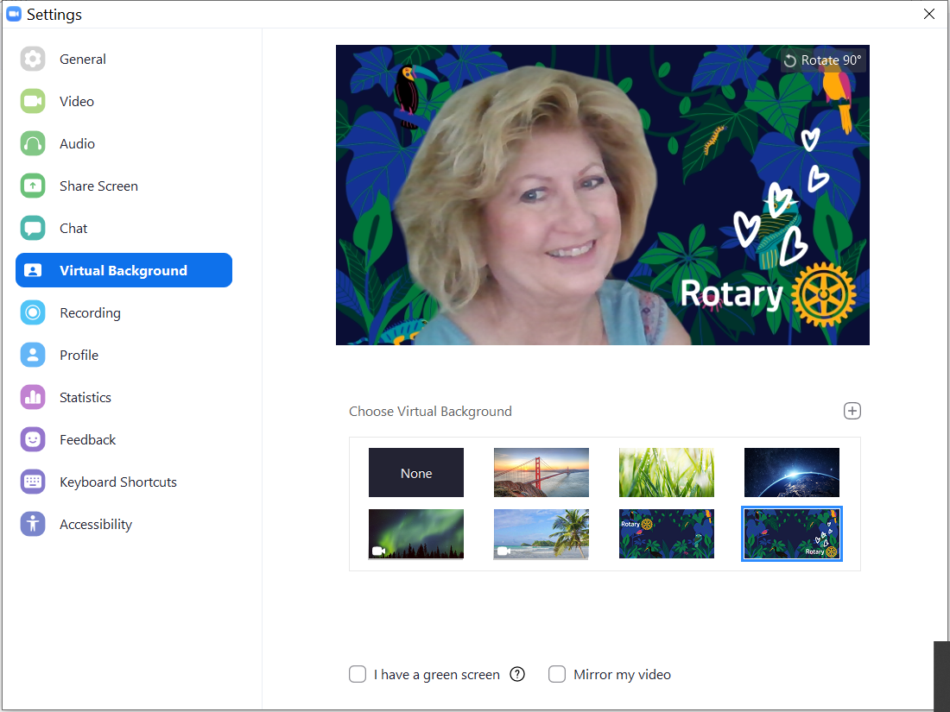
Note the options at the bottom of your screen. UNCHECK both boxes. Your computer may download a “green screen” for you (let it). Then, choose one of Zoom’s backgrounds OR click the + and upload your own (you can use ours or make your own using Canva). That’s it! You’re a ZOOM PRO.

