Strategic Planning Committee Developing 3-Year Action Plan
Sixteen District 6890 Rotarians will be developing a Strategic Action Plan to guide the district though the next three years. The committee’s purpose is to identify district priorities and to ensure the focus remains on supporting clubs, their members and Rotary International.
Chairperson for the endeavor is Scott Dudley, a member of Rotary Club of Winter Haven and a Past District 5050 Governor who served areas of Washington state and Canada. The committee’s first meeting is scheduled via zoom at 6 p.m. Thursday, Sept. 14. Three additional Zoom sessions and email communication likely will be needed to develop the plan within a 2-month time frame. Ultimately the plan will need to be adopted by the District 6890 Board of Directors.
District 6890 bylaws call for a 3-5-year strategic plan, updated annually. The most recent plan was developed in 2017. The new 2023-2026 plan is expected to align with the four priorities in the Rotary International Action Plan: Increase our impact, expand our reach, enhance participant engagement, and increase our ability to adapt.
In addition to chairperson Dudley, committee members representing each of the nine district areas include: 1 – Karen Frashier, New Tampa; 2 – Keith Hunnicutt, Avon Park; 3 – Connie Gage, Tampa; 4 – Chad Norgard, Brandon 86; 5 – Kim Christoffersen, Lakeland Sunrise; 6 – Diane Smith, Hardee County; 7 – Ellen “Pixie” Kehoe, Haines City; 8 – Clarice Roth, Bartow; and 9 – Kathleen Stasia, Sun City Center.
District bylaws also designate six district leaders to participate in the planning process: DG Steve Overton, Sun City Center; DGE Chevon Baccus, The Ridge; DGN Linda Devine, Tampa; iPDG Debbie Meegan, Brandon; Secretary Brooke Melendi; and Treasurer McQueen Small.
Members are encouraged to provide input to any committee member or by emailing DGE Chevon Baccus at RotaryChevon@aol.com.
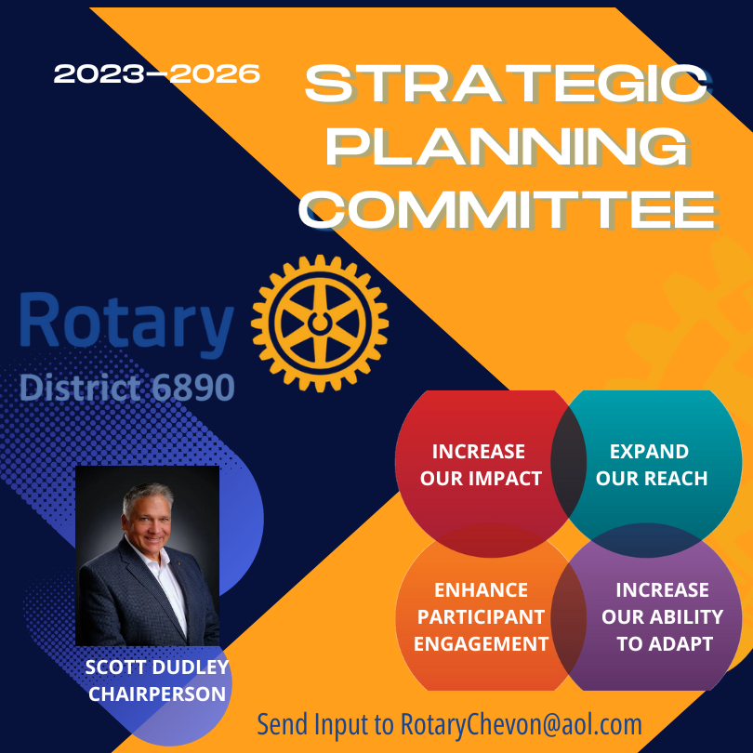

• Increase our impact • Expand our reach • Enhance participant engagement • Increase our ability to adapt

G Steve Overto
DGE Chevon Baccus
DGN Linda Devine
iPDG Debbie Meegan
Secretary Brooke Melendi
Treasurer McQueen Small
Our goal is for the plan to help current and future district governors work on the same overarching priorities, all focused on the district’s purpose to serve clubs and their members.
We are hoping to complete the 2023-26 Strategic Plan within the next couple of months via 4 Zoom sessions. Please look over the RI Action Plan brochure (attached) and bring your best ideas to the first meeting. Committee work between Zoom calls will be conducted via e-mail.
Strategic Planning Committee
Chairperson Scott Dudley, Winter Haven
AREA REPRESENTATIVESOur District 6890 bylaws call for a 3-5 year strategic plan, updated annually. Our most recent plan (attached) was completed in 2017.
By virtue of your leadership positions, you are automatically members of the committee. As DGE it was my responsibility to appoint the chair and one Rotarian from each of our nine areas.
Scott Dudley, who served as District Governor in 2016-17 in District 5050 (parts of Washington state and Canada) will chair the committee. Scott lives in Haines City and is a member of the Rotary Club of Winter Haven.
Scott will be emailing you an invitation and link to join the first meeting via ZOOM at 6 p.m. Thursday, Sept. 14.
We expect the 2023-26 plan will be patterned after the four areas of the RI Action plan, and include not only goals and objectives but strategies, tactics, timelines and designations of who takes responsibility.
1 – Karen Frashier, New Tampa
2 – Keith Hunnicutt, Avon Park
3 – Connie Gage, Tampa
4 – Chad Norgard, Brandon 86
5 – Kim Christoffersen, Lakeland Sunrise
6 – Diane Smith, Hardee County
7 – Ellen “Pixie” Kehoe, Haines City
8 – Clarice Roth, Bartow
9 – Kathleen Stasia, Sun City Center
DISTRICT LEADERS (per bylaws)
DG Steve Overton, Sun City Center
DGE Chevon Baccus, The Ridge
DGN Linda Devine, Tampa
iPDG Debbie Meegan, Brandon
Secretary Brooke Melendi, Tampa
Treasurer McQueen Small, Lake Placid

