Rotary International President 2024-25 Stephanie Urchick

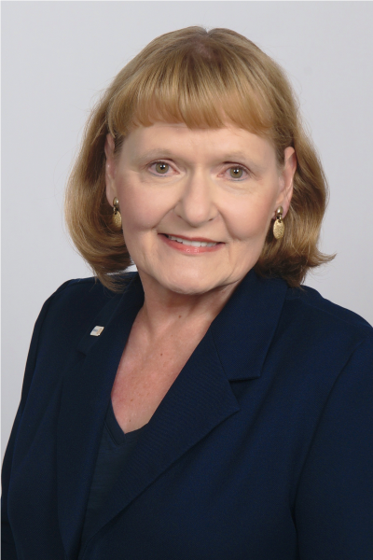

Stephanie A. Urchick, of the Rotary Club of McMurray, Pennsylvania, USA, is the selection of the Nominating Committee for President of Rotary International for 2024-25, a decision that would make her only the second woman to hold that position.

She will be declared the president-nominee on 15 September if no challenging candidates have been suggested.

With the world facing incredible challenges, including the COVID-19 pandemic, disasters driven by climate change, and conflict in many regions, Urchick says Rotary’s leaders can offer a vision and a plan for overcoming these challenges.

“Measures taken by Rotary leadership to survive and end critical challenges often make our organization stronger and more resilient for future events,” Urchick says. “This kind of essential leadership also creates new levels of cooperation, even among rivals, when Rotarians pull together as people of action to serve and solve a crisis.”

Making regionalization a priority is crucial, says Urchick. “Because Rotary operates in more than 200 countries and regions, it is vital to recognize that the organization has the potential to become more efficient and effective by understanding and reacting to how regional differences affect the way Rotarians work together to address providing service, promoting integrity, and advancing world understanding, goodwill, & peace,”

Urchick is a partner and chief operating officer of Doctors at Work LLC, a consulting and training company. She holds a doctorate in leadership studies from Indiana University of Pennsylvania. She is active on numerous community boards and committees and has been honored by organizations including Zonta International and the Sons of the American Revolution.

A Rotary member since 1991, Urchick has traveled to Vietnam to help build a primary school and to the Dominican Republic to install water filters. She studies several Slavic languages, has mentored new Rotarians in Ukraine, and coordinated a Rotary Foundation grant project in Poland.

Urchick has served Rotary in many roles, including as a director, Foundation trustee, and chair of the RI Strategic Planning Committee and the Foundation’s Centennial Celebration Committee. She currently serves on the Election Review Committee and the Operations Review Committee. She is a Rotary Foundation Major Donor and a member of the Bequest Society.