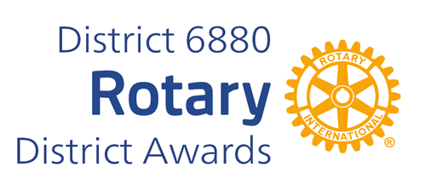
STEVE JAMES YOUTH SERVICE AWARD
Steve James Youth Service Award was established in 2015 in honor of Steve James who had an unfailing commitment to Rotary and especially young people.
Steve served as Secretary and President of the Jackson Club. He also sponsored his beloved interact club.
On the District level he was cochair of the Rotary Youth Leadership Academy (RYLA) and facilitated the Leadership Academy in 2013.
Steve received the Rotary International Vocational Award. Steve was honored as Jackson Citizen of the Year in 2015. Steve passed in 2016.
The Steve James Award for Distinguished Youth Service recognizes the individual who has contributed to the overall betterment of youth in their community and around the District by exemplary service and a cheerful heart.
You may complete and submit this form online on or before March 1st, 2026 to District Award Committee at Vimalpravin@gmail.com
OR
You may download this form and post US mail to The District Award Committee, P. O. Box 9184, Dothan, AL 36304, to be received before March 1, 2026.

Any questions should be directed to DGN Vimal Patel
at his email address, at Vimalpravin@gmail.com

Mobile Phone: 334-268-9909

STEVE JAMES YOUTH SERVICE AWARD
NOMINATION FORM

DATE:
ROTARY CLUB OF:
CLUB PRESIDENT'S NAME:
ADDRESS:
TELEPHONE NUMBER:
E-MAIL ADDRESS:
BASIS FOR NOMINATION: ( add page if needed)

___________________________________________
CLUB PRESIDENT'S SIGNATURE

