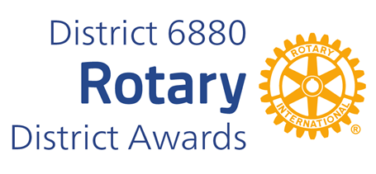
SOCIAL MEDIA AWARD
The Social Media Award was established in 2013 by District Governor Jim Golson (2012-13) to recognize Clubs meeting the challenge of communicating in new ways.
The Award is given to a small, a medium, and a large size club with the most active and diverse page using social media (Facebook, Linkedin and/or Twitter).
Selection is determined by evaluating the social media based on the following criteria:
SELECTION CRITERIA
1. Information about the Club (service projects, member news and recognitions, budgets, etc. 30%
2. Information about past, current and upcoming programs and speakers of the club. 20%
3. Information about Rotary International and The Rotary Foundation. 20%
4. Information about activities of the district. 10%
5. Appearance – attractiveness, formatted so that it is easy to read and easily understood. 10%
6. Other – community news, anecdotes, inspiration, humor, etc. 10% Total 100%
You may complete and submit this form online on or before March 1st, 2026 to District Award Committee at Vimalpravin@gmail.com
OR
You may download this form and post US mail to The District Award Committee, P. O. Box 9134, Dothan, AL 36304 , to be received before March 1, 2026.
Any questions should be directed to DGN Vimal Patel
at his email address, at Vimalpravin@gmail.com or
Mobile Phone: 334-268-9909

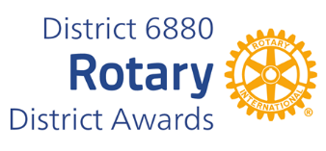
SOCIAL MEDIA AWARD NOMINATION FORM

DATE:
ROTARY CLUB OF:
CLUB PRESIDENT'S NAME:
ADDRESS:
TELEPHONE NUMBER:
E-MAIL ADDRESS:
Social Media Site Address(es):
INDICATE CLUB SIZE:
Under 40 members. 41 to 99 members. Over 100 members.

_____________________________________________________
CLUB PRESIDENT'S SIGNATURE

