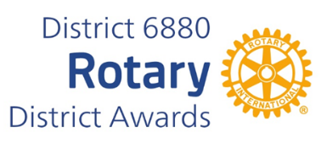
HENRY HARRISON LONGEVITY AWARD
NOMINATION FORM

The award is named for Henry Harrison, who in 2019 became a 100 year old member of the Demopolis Rotary Club and former member of the Linden Club. He served both with distinction throughout his more than 72 years as a Rotarian.
The Henry Harrison Award, established in 2019 by District Governor Sam Adams (2018-2019), recognizes the contributions of senior members of Rotary and their long service with their clubs, districts, zones and/or Rotary International.
To be eligible for the Henry Harrison Award, a member must be at least 75 years of age, a Rotarian for a minimum of 25 years and have earned Paul Harris Fellow status. The nominee shall have served as a past club president or district officer show regular meeting attendance and demonstrate active service to his club and community.
You may complete and submit this form online on or before March 1st, 2026, to District Award Committee at Vimalpravin@gmail.com

OR
You may download this form and post US mail to The District Award Committee, P. O. Box 9184, Dothan, AL 36304, to be received before March 1, 2026.

Any questions should be directed to DGN Vimal Patel
at his email address, at Vimalpravin@gmail.com

7Mobile Phone: 334-268-9909

HENRY HARRISON LONGEVITY AWARD
NOMINATION FORM

DATE:
ROTARY CLUB OF:
CLUB PRESIDENT'S NAME:
ADDRESS:
TELEPHONE NUMBER:
E-MAIL ADDRESS:
NAME OF NOMINEE:
ADDRESS:
ROTARIAN SINCE:
BASIS FOR NOMINATION: (add page if needed)

___________________________________________
CLUB PRESIDENT'S SIGNATURE

