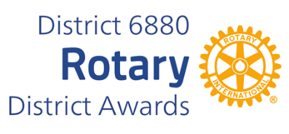
HARRY P. HALL MERITORIOUS AWARD
The Harry P. Hall Meritorious Award was established in 1981 by District Governor Charles H. Chapman (1981-82), and 1977 Charter President of the Rotary Club of Dothan-Houston County.
His purpose in beginning the award was to recognize Rotarians in District 688 (now 6880) who exemplify the motto of Rotary International in a distinguished and significant manner.
Governor Charles chose to name the award for Past District Governor Harry P. Hall (1941- 42), a member of the Rotary Club of Dothan. At the time DG Harry served as governor, the district number was 164, and it covered the entire state of Alabama.
The first motto of Rotary International, He Profits Most Who Serves Best, was approved at the second Rotary Convention in August 1911. DG Charles recognized PDG Harry's commitment to the ideals of Rotary as expressed in the motto. [It was not until 1989 that Service Above Self was established as the principal motto of Rotary.]
The Harry P. Hall Meritorious Award is now recognized as the most coveted honor that District 6880 Rotarians bestow, since it exemplifies that same principle of unselfish volunteer service as expressed throughout Rotary's rich history.
You may complete and submit this form online on or before March 1st, 2026 to District Award Committee at vimalpravin@gmail.com OR
you may download this form and post US mail to The District Award Committee, P. O. Box 9184, Dothan, AL 36304 to be received before March 1, 2026.

Any questions should be directed to DGN Vimal Patel at his email address, at vimalpravin@gmail.com

Mobile Phone: 334-268-9909

HARRY P. HALL MERITORIOUS AWARD NOMINATION FORM
DATE:
ROTARY CLUB OF:
CLUB PRESIDENT'S NAME:
ADDRESS:
TELEPHONE NUMBER:
E-MAIL ADDRESS:
NAME OF NOMINEE:
ADDRESS:
ROTARIAN SINCE:
BASIS FOR NOMINATION: (add page if needed)

____________________________________________________
CLUB PRESIDENT'S SIGNATURE

