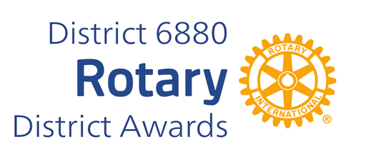
AVENUES OF SERVICE CITATION NOMINATION

The Avenues of Service Citation for Individual Rotarians provides a way for presidents of Rotary clubs to personally recognize one club member for his or her outstanding efforts In the five Avenues of Service.
A club member must have demonstrated support of the object of Rotary through active participation In each of the five Avenues of Service: Club, Vocational, Community, International, and Youth Service. Nominees must be an active Rotarian and can only receive the Award once.
You may complete and submit this form online on or before March 1st, 2026, to District Award Committee at vimalpravin@gmail.com
OR
You may download this form and post US mail to The District Award Committee, P.O. Box 9184, Dothan, AL 36304 to be received before March 1, 2026.

Any questions should be directed to DGN Vimal Patel
at his email address, at vimalpravin@gmail.com

or Mobile Phone: 334-268-9909

AVENUES OF SERVICE CITATION NOMINATION FORM

DATE:
ROTARY CLUB OF:
CLUB PRESIDENT'S NAME:
ADDRESS:
TELEPHONE NUMBER:
E-MAIL ADDRESS:
NAME OF NOMINEE:
NOMINEE ADDRESS:
ROTARIAN SINCE:
BASIS FOR NOMINATION: (add page if needed)

______________________________________________
CLUB PRESIDENT'S SIGNATURE

