CHAMBERS ACADEMY
December 1, 2020 - Press Release
Chambers Academy – 15048 US Highway 431 – LaFayette, AL 36862
Office – 334-864-9852 – Fax – 334-864-9691 – david.owen@chambersacademy.com

Sharing from on behalf of our students at Chambers Academy:

CA’s eleventh grade environmental science class volunteered yesterday to serve as Christmas Elves for the LaFayette Rotary Club’s Santa outreach to the community area nursing home residents. The LaFayette Rotary Club annually conducts outreach to provide Christmas gift bags stuffed with gift items for LaFayette’s area nursing home residents. This year, Chambers Academy teacher, Mr. Jon Reynolds volunteered his environmental science class to help organize, sort and fill the gift bags with a variety of thoughtful gift items purchased by the LaFayette Rotary Club for the area’s nursing home residents.

The CA students were honored to serve and assist the Rotary Club on such a noble cause to help ensure that the residents in this time of the pandemic would not be forgotten during this holiday season. The students helped prepare 117 individual holiday gift bags to be delivered next week. Special thanks to LaFayette Rotary Club Christmas project leader, Mrs. Dianne Sherriff for coordinating the club’s efforts with the students at Chambers Academy. Also, CA Headmaster David Owen commended the students for making a difference to serve others for this Christmas season.

Pictured below are several photos of the students enjoying their work as elves for Rotary Club.

Many thanks for sharing this with our local community!

Sincerely,
David Owen
Headmaster
Chambers Academy

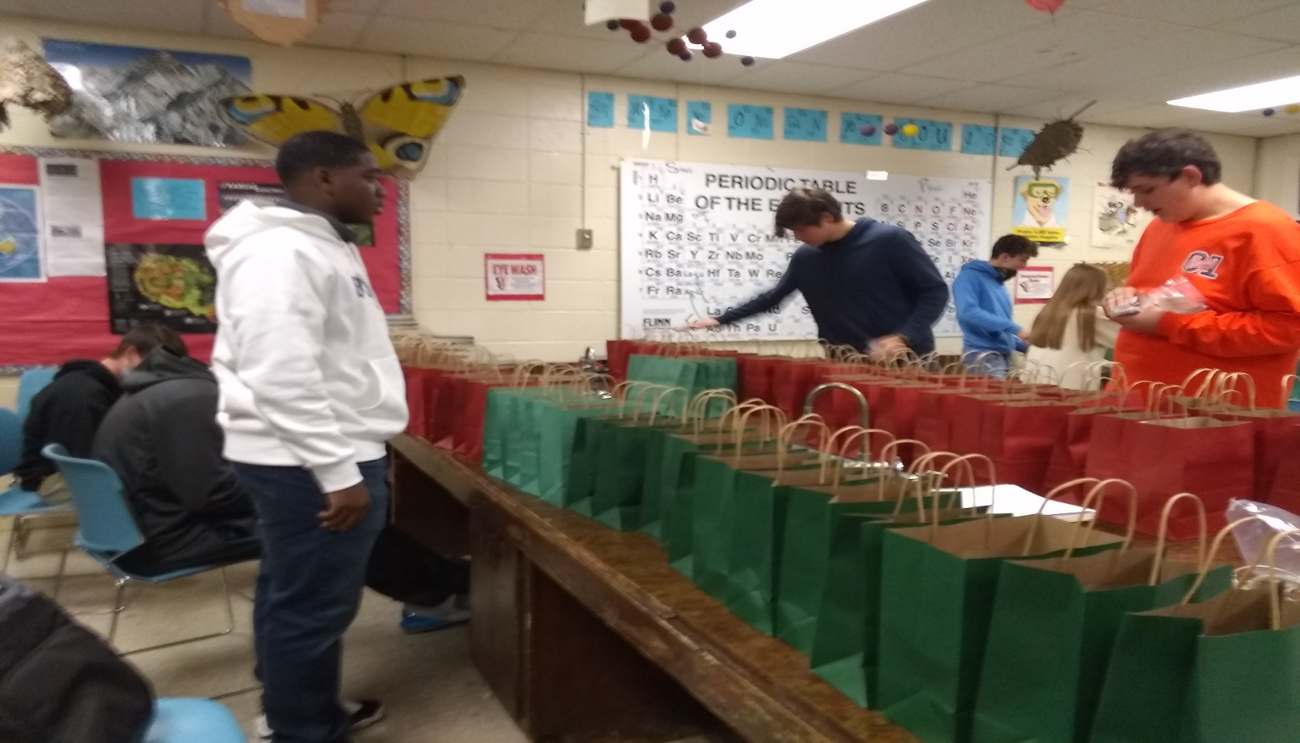
Juniors jarquez Banks, Jacob Brown and Benjamin Caulfield stuff gift bags while other students are putting cards together.
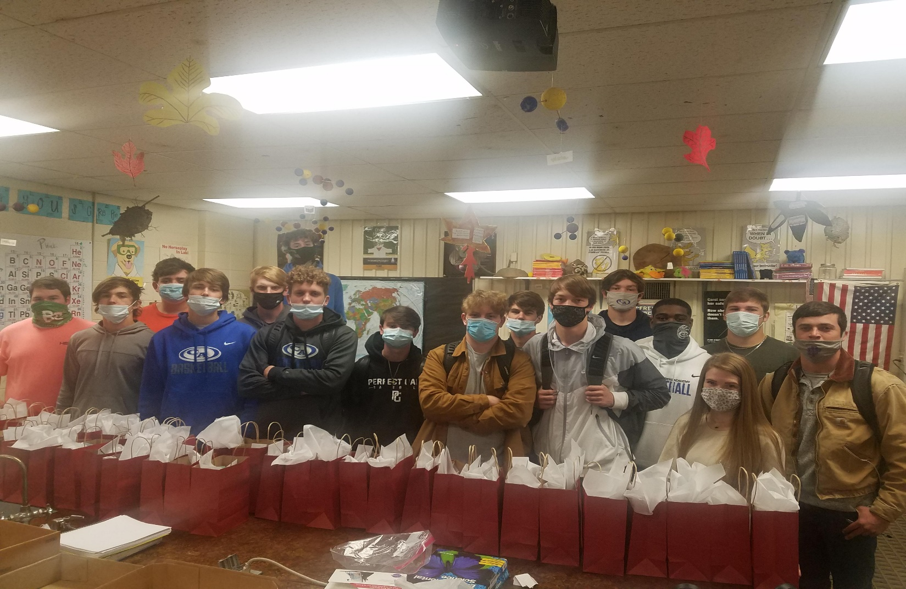
Mr. Jon Reynolds eleventh grade environmental science class poses with some of the 117 gift bags stuffed for the LaFayette Rotary Club for area nursing home residents.
CA students hard at work enjoying their efforts to sort the gift bags for the Rotary Club’s outreach to nursing home residents in LaFayette.

