19 04 02 – Meeting Notes
Moores Creek Project
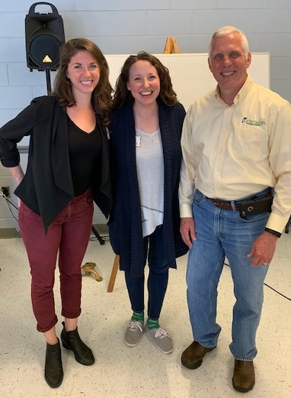
Pictured left to right: Extension Watershed Assistant Coordinator Laura Bell, Extension Watershed Coordinator Alex James, and Chambers County Extension Coordinator Ken McMillan.
On April 2, 2019 Alex James and Laura Bell provided the LaFayette Rotary Club an engaging educational program on the Moores Creek Project. Moores Creek Project Phase 1 ($522,000) was completed near Lanett High School in 2017. The Project Phase 2 ($303,000) is an opportunity to continue improving the health of our water resources in Lanett and Valley. Alex discussed many of the factors affecting the Creek’s health as well as ways we can scientifically assess the stream’s water through Chemistry and Benthic Macroinvertebrate monitoring. By collecting and analyzing the presence of various aquatic macroinvertebrates (bottom dwelling organisms that can be seen without a microscope), scientists and volunteers can figure out the relative health of a stream system and its watershed. Monitors hope to collect a wide variety of these backboneless organisms having various tolerances to pollution.
The Project Phase 2 efforts also include Stream Restoration near Valley City Hall, Technical Tours, youth education through 4-H, and watershed trash cleanups this month. Alex James can be reached at las0008@auburn.edu or (334) 844-3809.

