Rotary International District 6860
Mid-Year Finance Committee Meeting Minutes
October 29, 2020 2:00 pm via Zoom
PDG Carol Argo, Finance Committee Chair
Lindsy Gardner, Secretary
Members Present:
PDG Carol Argo, PDG Bill Petty, PDG JG Brazil, Ronnie Smallwood, PDG Georgia Medori, DG Lee Weinman, DGE Harold Lewis, Tommie Goggans, DGN Mike Wade, Lindsy Gardner
Guests Present:
PDG Wade Drinkard, Jim Shepherd, Will Ratliff
Members Absent: Phil Fowler, Mark Hendrix, Bubba Masters
District Finance Chair PDG Carol Argo called the meeting to order at 2:00 pm, welcomed all in attendance, and called for introductions.
OLD BUSINESS
Review of District Mid-term Finance Committee minutes
PDG Petty pointed out that DGN Wade was on both the present and absent members lists. DGN Wade was present at the meeting.
MOTION: DGE Harold Lewis motioned to accept the minutes as amended, seconded by DG Lee Weinman. Motion approved unanimously.
PayPal account
Ronnie Smallwood reported a concerted and cooperative, but ultimately unsuccessful effort to transfer the PayPal account. PDG Bill Petty will approach Doug Crump to confer on the issue.
QuickBooks
Ronnie Smallwood has researched options for converting from the desktop version of Quick Books to Quick Books Online. He suggests planning the conversion to coincide with the beginning of the next fiscal year. After some discussion, PDG Argo encouraged DGE Lewis to work towards implementation next year.
NEW BUSINESS
Peace Symposium/New Generation
DG Weinman introduced the Build Peace. Repeat the Peace: Metro Birmingham 20-21 initiative as a program of the Peace Conference slated to be held in Birmingham in 2023. DG Weinman recognized Will Ratliff and Jim Shepherd to give further details on the project. Will Ratliff explained that Build Peace. Repeat the Peace. is a project-based education program for teens in grades 9-12. While Ratliff hoped that the program would eventually be offered throughout the District, the 2021 pilot program will focus on high schools and youth service organizations in the Birmingham area.
Ratliff summarized that the progress on this project. Building Peace, Inc has been established as a non-profit organization to administer the Peace Conference and youth education program. Building Peace, Inc. has applied for tax-exempt status under IRS section 501(c)3 but has not yet received its IRS determination letter. Building Peace, Inc has signed a contract with NewGen, a company in North Carolina recommended by Rotary International, to design and implement the youth education program in Birmingham. The contract with NewGen has an obligation of $30,000 with quarterly payments of $7,500. The first quarter invoice was paid with funds raised by the Rotary Club of Birmingham for that purpose.
In order to raise the balance of the funds for the youth education program, Building Peace, Inc approached a company called Affinity Travel Benefits, also recommended by Rotary International, to create and launch an electronic fundraising campaign with a goal of $45,000 - $50,000. Fundraising costs are included in the goal.
Building Peace, Inc asked District 6860 to sign the contract with Affinity Travel Benefits and pay the initial $5,000 fee to begin the fundraising campaign. Since fundraising costs are included in the campaign goal, District 6860 should be reimbursed for the initial $5,000 and other on-going costs related to Affinity Travel Benefits. Ronnie Smallwood confirmed that funds for the youth education program would be appropriately segregated from District 6860 operating funds.
The email fundraising campaign will primarily be focused on Rotarians in District 6860 with an emphasis on the Birmingham area club members. PDG Argo pointed out that Rotary Clubs do not have tax-exempt status under IRS section 501(c)3. Since Building Peace, Inc. is still awaiting determination from the IRS, the Finance Committee discussed avenues for giving that would ensure that contributions are tax-deductible. Ratliff and Shepherd will pursue partnerships with local Rotary Club foundations to achieve this objective.
DG Weinman will work with Shepherd to secure a list of email addresses of Rotarians for the fundraising campaign. PDG Argo reminded Shepherd that Rotarians who have opted out of receiving emails should be excluded.
Update on 2020-2021 DDF
PDG Wade Drinkard, District Rotary Foundation Chair, reported that $50,261 in DDF are available at this date based on the revenue and expenses listed below.
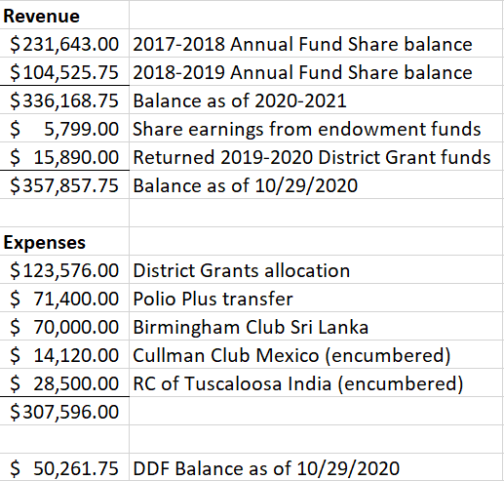
PDG Drinkard also reported that 29 clubs had applied for District grants for a total of 43 projects. The maximum grant award is $4,395.
PDG Drinkard outlined The Rotary Foundation giving for District 6860 as of October 29, 2020.
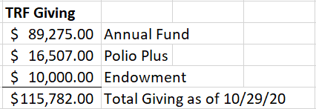
The Finance Committee also discussed the Les Wright fund and Glenn Estess, Sr. fund in the endowment to support Global Scholars. PDG Argo reported that District 6860 is currently sponsoring two Global Scholars who are studying in England.
DG Weinman announced that Rotarians in District 6860 raised about $100,000, including matching funds, for the Purple Pinky Doughnut project. He will ask District Polio Plus Chair, John Beard, to send a report to all clubs who participated.
Review of Financials July September 2020
PDG Petty shared the Income and Expense Budget vs Actual and Open Invoices reports digitally.
PDG Petty presented the year-to-date financials to the Finance Committee. He pointed out current net income is $85,177.85, primarily due to curtailing of travel and other expenses during COVID-19. PDG Argo asked the District to consider refunding money to clubs at the end of the year if feasible.
The Finance Committee also reviewed open invoices. A second notice will go to clubs on November 1. DG Weinman will approach club Presidents and then get the Assistant Governors involved, per the District Leadership Plan. The invoices do not include any expenses related to President-Elect Training registration because the actual costs have not been determined yet.
MOTION: Tommy Goggans made a motion to approve the financials as presented, seconded by PDG Georgia Medori. Motion passed.
Status of District Block Grant Audit for 2019-2020
DG Weinman confirmed that William Ross will chair the District Block Grant Audit for 2019-2020. DG Weinman will follow up with William Ross.
Year-End Review of Financials 2019-2020
PDG Petty shared the 2019-2020 Income vs Expense report and Balance Sheet digitally. He reported net income of $40,293 for the year, primarily due to reduced expenses during COVID. The Rotary Club of Birmingham funded a significant portion of expenses related to the Foundation Dinner, which also contributed to a positive net income.
Motion: DG Lee Weinman made a motion to approve the 2019-2020 financial report as presented. DGE Harold Lewis seconded. Motion passed.
Review of 990 for 2019
PDG Petty shared the Form 990 for 2019 digitally. The 990 was prepared by Morrison & Smith at a cost of $1,700. Morrison & Smith did not report any significant issues in preparation of the 990.
PDG Argo asked DGE Lewis to research accountants who may be willing to provide the 2020 990 pro bono. DGE Lewis concurred.
Motion: Tommie Goggans made a motion to approve the 990. PDG Georgia Medori seconded. Motion passed.
Status of Independent Review of 2019-2020 Financials
The Finance Committee discussed the role and responsibilities of the Independent Review Committee. The Finance Committee expects the independent review of the 2019-2020 financials by the Mid-Year Conference.
Other New Business
PDG Argo reminded DGE Lewis that he would be invited to present his budget to the Finance Committee at the winter meeting.
PDG Argo announced that the review of the District Leadership Plan would include complete examination of the finance sections.
PDG Argo adjourned the meeting at 2:20 pm.
Respectfully submitted,
Lindsy Gardner

