District 6860 1st Annual Interact Event
April 20, 2013
Guntersville State Park
Guntersville, Alabama 35976



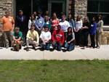

Interact Clubs represented at the 2013 Annual Meeting:

Rotary Club of Madison
Rotary Club of Aliceville
Rotary Club of Gardendale
Rotary Club of Guntersville Sunrise
Rotary Club of Albertville
Rotary Club of Boaz
Rotary Club of Trussville Sunrise

FUN!!!!!

