Rotary Club of Fairfield Glade
Club - 3856

District 6780 – Greg Maciolek, Governor

Box 1937, Fairfield Glade, TN 38558

www.ffgrotary.org

Facebook: Rotary Club of Fairfield Glade

Meetings
Tuesdays Legends at Druid Hills Country Club in Fairfield Glade. Lunch starting at 11:30 a.m., Meeting 12:00 p.m. to 1 p.m.
Officers
President - Deb Birdsall
President Elect – Colleen Mall
President Nominee – John Kindschi
Secretary - Mary Jane Ware
Treasurer - Bob Weber
Past President – Tessi Gilmer
Sgt at Arms – Marcie Loffredo

Board of Directors
Officers plus
Doug Cooper - Service Programs
Crystal Davis - Membership
Jeff Townsend - Foundation
Kevin Troyana - Youth Services
Charles Lusso – Administration
Allen Snow – Public Image
Future Programs
Sep. 10: Birdsall - Club Board mtg.
J. Williams - Final Prep for Music Festival
Sep. 17 – MJ Ware DacDB training for
New members.
Dates to Remember
Sept 14 Music Festival
Sept 21 RYLA Camp at Camp Nakanawa
Make ups: On the web: www.rotaryeclubone.org Crossville: Wed. 6:30 AM, Crossville Breakfast Club, Cumberland Medical Center; Thur. Noon, Crossville Noon Club, Cumberland Mountain State Park
ROTA NEWS
September 3, 2019

Today's Program
Gabe Powell – Army Sand Table Modeling/Census Report

Last week’s meeting
Last weeks meeting was the last meeting of the first two months of this year. We’re off to a very good start for this year with 11 new club members and 4 new Paul Harris Society members.
The highlight of the meeting was the visit of District Governor Greg Maciolek escorted by his Secret Service Detail. Greg attended our Board meeting asking several questions, making some comments and suggestions. His presentation gave us insight into his plans and goals for this year.
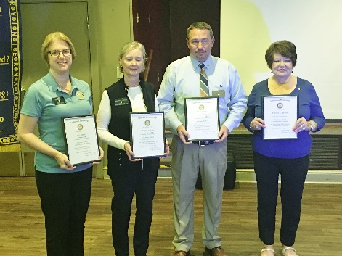
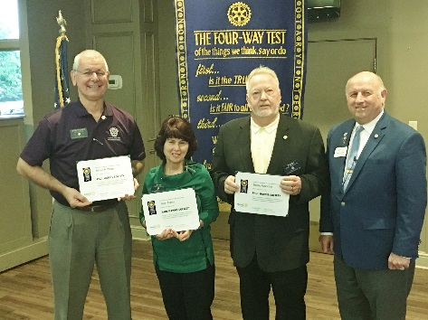
New club members. New Paul Harris Society members.
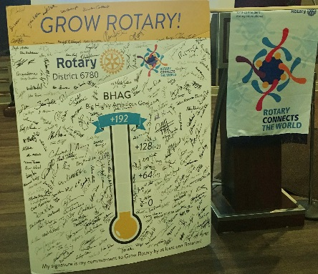
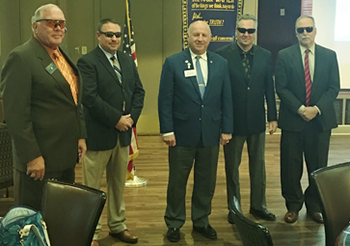
This years goal Grow Rotary. After checking everyone, frisking
One guilty looking member and
Disarming a bomb the security
Detail pronounced everyone safe.

Rotary Grace
We break the bread which comes from you, and thank you Lord for all things true. May we, more blessed than we deserve, live less for self and more to serve.

