Rotary Club of Fairfield Glade
Club - 3856

District 6780 – James Roxlo, Governor

Box 1937, Fairfield Glade, TN 38558

www.ffgrotary.org
Facebook: Rotary Club of Fairfield Glade

Meetings
Tuesdays Legends at Druid Hills Country Club in Fairfield Glade. Lunch starting at 11:30 a.m., Meeting 12:00 p.m. to 1 p.m.
Officers
President - Deb Birdsall
President Elect – Colleen Mall
President Nominee – John Kindschi
Secretary - Mary Jane Ware
Treasurer - Bob Weber
Past President – Tessi Gilmer
Sgt at Arms – Marcie Loffredo

Board of Directors
Officers plus
Doug Cooper Service Programs
Crystal Davis - Membership
Jeff Townsend - Foundation
Kennetha Wattenbarger - Youth Services
Charles Lusso – Administration
Allen Snow – Public Image
Future Programs
July 9 Board Mtg/
July 16 Blake & Myrta –Cuba Revisited

Dates to Remember
July 14 Flotilla Dartmoor
Aug 11 FGRF Fund raiser Concert
Sept 14 Music Festival
ROTA NEWS
July 9, 2019

Today's Program
Sally Nash from the CMC Wellness Center will talk about senior wellness programs for our members.
Last week’s meeting
President and Committee Chairs describe their roles, goals and
Needs.
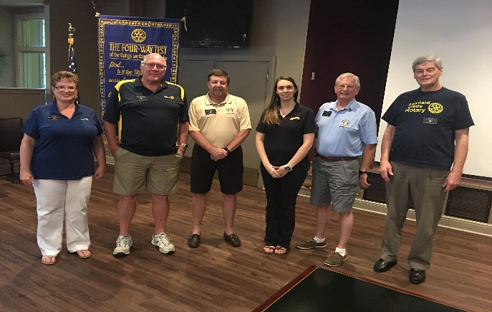
Deb Birdsall, Chales Lusso, Bob Christian, Crystal Davis, Jeff Townsend & Allen Snow

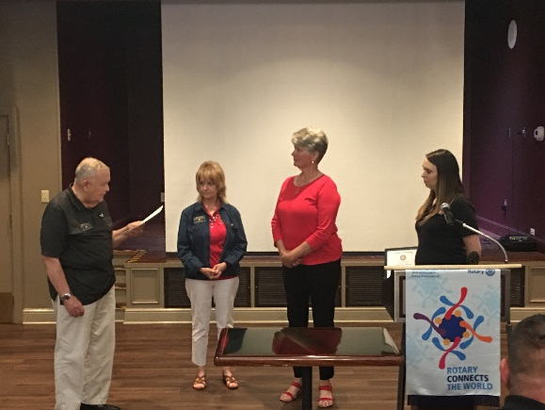
New member Cathy Farnham was inducted.

Rotary Grace
We break the bread which comes from you, and thank you Lord for all things true. May we, more blessed than we deserve, live less for self and more to serve.

Make ups: On the web: www.rotaryeclubone.org Crossville: Wed. 6:30 AM, Crossville Breakfast Club, Cumberland Medical Center; Thur. Noon, Crossville Noon Club, Cumberland Mountain State Park

