

Rotary Club of Fairfield Glade

Club - 3856

District 6780 – James Roxlo, Governor

Box 1937, Fairfield Glade, TN 38558

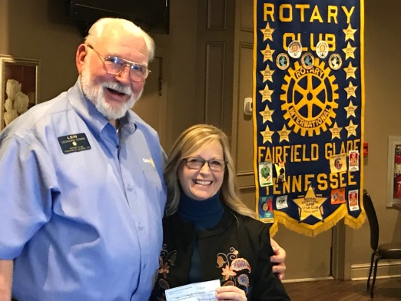www.ffgrotary.org

Facebook: Rotary Club of Fairfield Glade

Meetings

Tuesdays Legends at Druid Hills Country Club in Fairfield Glade. Lunch starting at 11:30 a.m., Meeting 12:00 p.m. to 1 p.m.

Officers

President - Tessi Gilmer

President Elect - Deb Birdsall

President Nominee – Colleen Mall

Secretary - Mary Jane Ware

Treasurer - Bob Weber

Past President – Jack Williams

Sgt at Arms - Jack Baggett

Board of Directors

|  |
| --- |
| Officers plus |
| Dick Sammer- Service Programs |
| Chrystal Davis - Membership |
| Bill Collins - Foundation |
| Tessi Gilmer - Youth Services |
| Charles Lusso – Administration |
| Jeff Townsend – Public Relations |
|  |
|  |

Future Programs

Jan 29 Mike Williams Public Safety

Feb 5 New mbr Inductions Chrystal Davis Back Pack Program

Feb 12 Jack Williams Carlos Doesn't Remember

Feb 19 Dr.Jancek - Conflict Resolution

**D**ates to Remember

Jan 29 Service Project Bread of Life

March 19 Royal Hounds Concert

Palace Theater

April 5-6 District Conference Gatlinburg

Apr 27 Wine On The Plateau

Sept 14 Music Festival

ROTA  NEWS

January 22, 2019

Today's Program

D. Beatty- Principal of Crab Orchard Elem School

Last week’s meeting

Tammy Stewart, President, Imagination Library received a Club donation from Len Stark and up-dated us on all the work that Imagination Library does to improve literacy in Cumberland County.



Pam Burris, Kids OnThe Rise, receiving our Donation from Charles Lusso following her presentation on what KOTR does to help kids in Cumberland County overcome disadvantages and succeed in school.

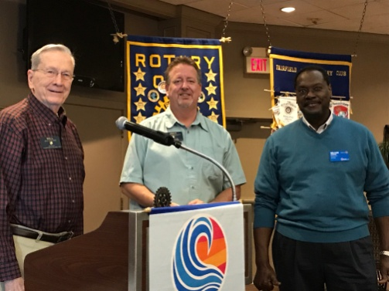 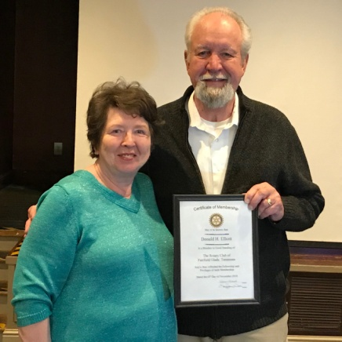

Announcing PHF +1 Baggett Don Elliot was inducted as and Wilson PHF +3 Rotarian with his wife DeAnna

Continues on back page

***Rotary Grace***

***We break the bread which comes from you, and thank you Lord for all things true. May we, more blessed than we deserve, live less for self and more to serve.***

**Make ups:** On the web**:** www.rotaryeclubone.org **Crossville:** Wed. 6:30 AM, Crossville Breakfast Club, Cumberland Medical Center; Thur. Noon, Crossville Noon Club, Cumberland Mountain State Park

Rotary Theme 2019-20



Awards from Alzheimer’s Tennessee for our Participation in the Alzheimer’s Walk in Crossville on Oct 13th

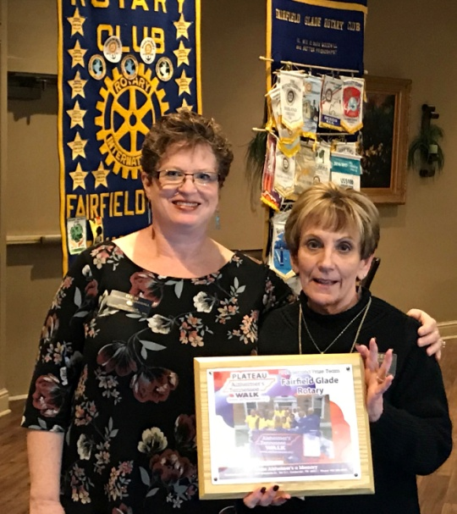

Deb Birdsall receiving the Plaque from Alzheimer’s TN

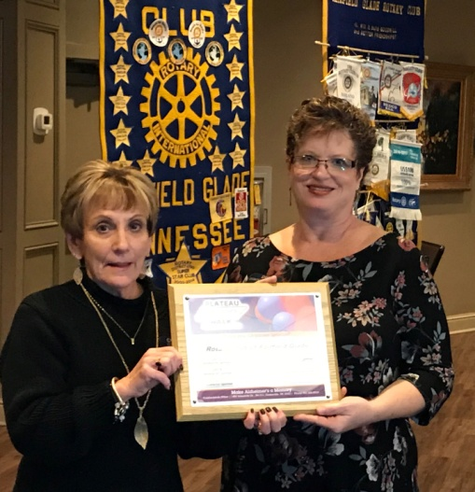

Our Award for 2nd Place in monies earned by walkers on October 13th.

Music & Memory Announcement

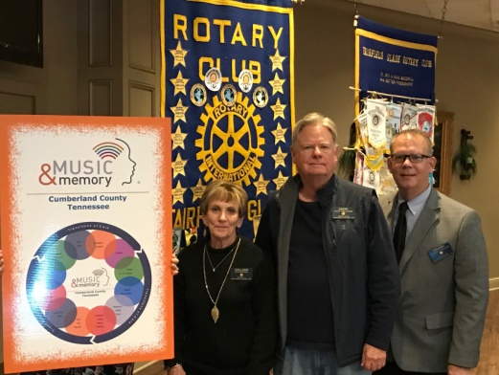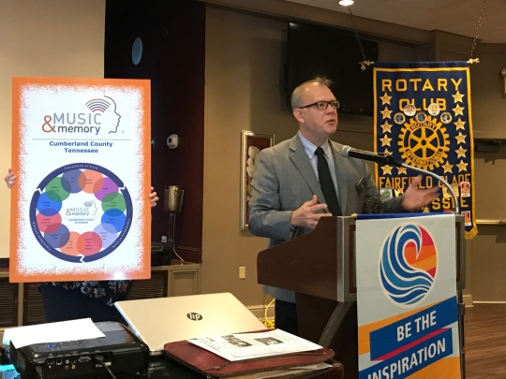

Frank Horvath, our Music & Memory Chair and Co-Chair of Music & Memory Cumberland County announcing that State of Tennessee has established a $1,000,000 Grant for Nursing Homes to implement Music and Memory. This 3 year grant from the Tennessee Dept of Health and Human Services takes Music and Memory to the next level.

Grants from this program will fund the clinical implementation (Professionally implemented, monitored, and documented) of Music & Memory by Certified Care Agencies such as Nursing Homes and hospitals.

Music & Memory use and playlists have become a medicine prescribed to improve patient treatment just like a medicine and placed in a patient’s medical records so it transitions with them as they move from Nursing Homes to hospitals or other medical facilities.

The concept of Music & Memory that our Club introduced in Cumberland County in 2015 with the showings of “Alive Inside” and first implementation through local nursing homes under Jack Williams has come a long way. Colleen Mall took Chair after Jack and then Frank Horvath took Music & Memory to the next level working with Music & Memory Inc.

He got Ed DeVries of FGRS to be co-chair of Music & Memory Cumberland Country got all of the agencies in Cumberland to work as a group to implement the Music & Memory Inc. and become Certified Care Agencies. Working with a group in an area instead of one at a time is a new approach for Music & Memory Inc and if it works as well as expected will become the new way for Music & Memory Inc to expand geographically.

Our goal was to bring Music to patients in Cumberland County who could benefit from individualized play lists. That was accomplished and now it is “going to the next level” as a formal medical practice prescribed for patients, in their medical records so it follows them and is implemented professionally as they move from medical facility to medical facility.

Cumberland County agencies using Music & Memory include Life Care Center, Upland Village (Certified), Wyndridge Health and Rehab, Fairfield Glade Assisted Living, Dominion Assisted Living, Good Samaritan Society, and Fairfield Glade Resident Services (Certified).