Rotary Club of Fairfield Glade
Club - 3856

District 6780 – Greg Maciolek, Governor

Box 1937, Fairfield Glade, TN 38558

www.ffgrotary.org

Facebook: Rotary Club of Fairfield Glade

Meetings
Tuesdays Legends at Druid Hills Country Club in Fairfield Glade. Lunch starting at 11:30 a.m., Meeting 12:00 p.m. to 1 p.m.
Officers
President - Deb Birdsall
President Elect – Colleen Mall
President Nominee – John Kindschi
Secretary - Mary Jane Ware
Treasurer - Bob Weber
Past President – Tessi Gilmer
Sgt at Arms – Marcie Loffredo

Board of Directors
Officers plus
Doug Cooper Service Programs
Crystal Davis - Membership
Jeff Townsend - Foundation
Kevin Troyana - Youth Services
Charles Lusso – Administration
Allen Snow – Public Image
Future Programs
Aug 20 Jack Williams – Oak Ridge Rotary – Haiti
Aug. 27 District Governor’s visit

Dates to Remember
Sept 14 Music Festival
Sept 21 RYLA Camp at Camp Nakanawa, Crossville
Make ups: On the web: www.rotaryeclubone.org Crossville: Wed. 6:30 AM, Crossville Breakfast Club, Cumberland Medical Center; Thur. Noon, Crossville Noon Club, Cumberland Mountain State Park
ROTA NEWS
August 13, 2019

Today's Program
Joyce Rorbough – Cumberland County Archives
Last week’s meeting
Jeff Townsend gave the FFG Rotary 2018 Annual Report
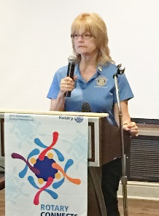
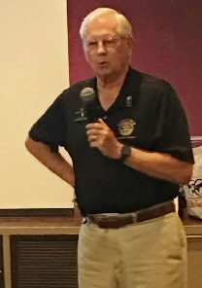
An excellent report Marcia’s
showing the growth member
and all the awards moment.
we were awarded.

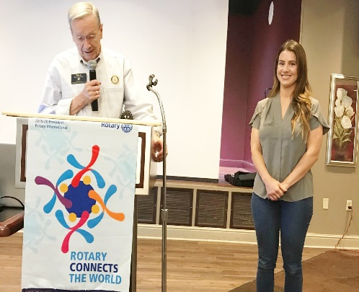
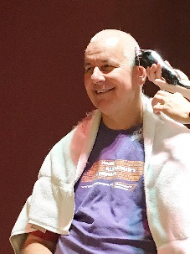
Nothing like a
Good haircut.
-------------------
Bill presents
Sarah Fletcher
The last of the
Fairfield Glade
Scholarships.

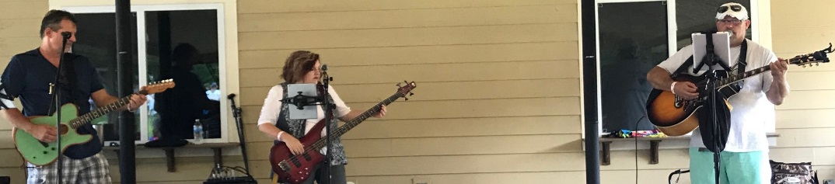

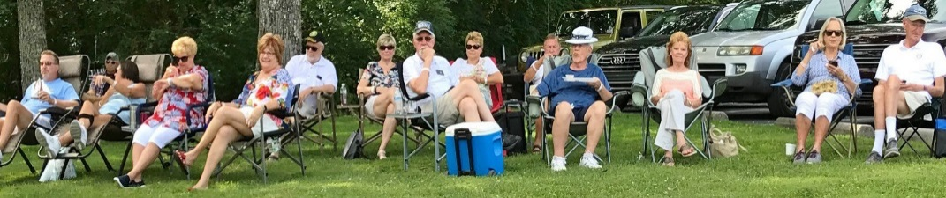

Rotary Grace
We break the bread which comes from you, and thank you Lord for all things true. May we, more blessed than we deserve, live less for self and more to serve.

