Rotary Club of Fairfield Glade
Club - 3856

District 6780 – Greg Maciolek, Governor

Box 1937, Fairfield Glade, TN 38558

www.ffgrotary.org

Facebook: Rotary Club of Fairfield Glade

Meetings
Tuesdays Legends at Druid Hills Country Club in Fairfield Glade. Lunch starting at 11:30 a.m., Meeting 12:00 p.m. to 1 p.m.
Officers
President - Deb Birdsall
President Elect – Colleen Mall
President Nominee – John Kindschi
Secretary - Mary Jane Ware
Treasurer - Bob Weber
Past President – Tessi Gilmer
Sgt at Arms – Marcie Loffredo

Board of Directors
Officers plus
Doug Cooper - Service Programs
Crystal Davis - Membership
Jeff Townsend - Foundation
Kevin Troyana - Youth Services
Charles Lusso – Administration
Allen Snow – Public Image
Future Programs
Sep. 3: Gabe Powell – Army Sand Table
Modeling/Census Report
Sep. 10: Birdsall - Club Board mtg.
J. Williams - Final Prep for Music Festival

Dates to Remember
Sept 14 Music Festival
Sept 21 RYLA Camp at Camp Nakanawa
Make ups: On the web: www.rotaryeclubone.org Crossville: Wed. 6:30 AM, Crossville Breakfast Club, Cumberland Medical Center; Thur. Noon, Crossville Noon Club, Cumberland Mountain State Park
ROTA NEWS
August 27, 2019

Today's Program

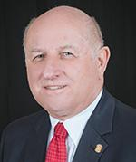
We welcome District Governor Greg Maciolek.
Greg joins us to discuss all the exciting things going
on in Rotary District 6780.

Last week’s meeting

Oak Ridge Rotary Club – Haiti Water Project

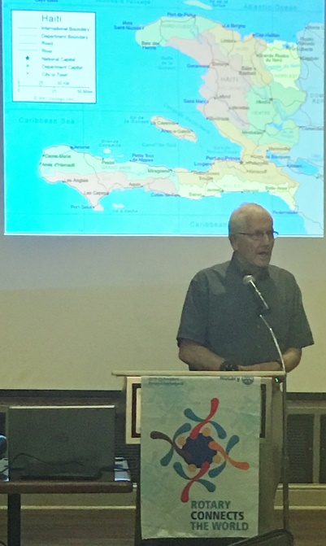
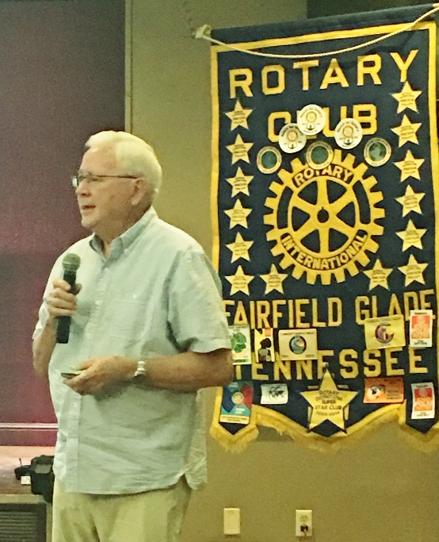
David Olsen and Jim Rushton
Gave an update on the Haiti water Project
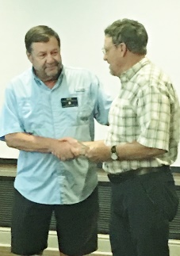

Bob Christian presents a check to
Don Hazel for Friends of the Trails

Rotary Grace
We break the bread which comes from you, and thank you Lord for all things true. May we, more blessed than we deserve, live less for self and more to serve.

