Rotary Club of Fairfield Glade
Club - 3856

District 6780 – Greg Maciolek, Governor

Box 1937, Fairfield Glade, TN 38558

www.ffgrotary.org

Facebook: Rotary Club of Fairfield Glade

Meetings
Tuesdays Legends at Druid Hills Country Club in Fairfield Glade. Lunch starting at 11:30 a.m., Meeting 12:00 p.m. to 1 p.m.
Officers
President - Deb Birdsall
President Elect – Colleen Mall
President Nominee – John Kindschi
Secretary - Mary Jane Ware
Treasurer - Bob Weber
Past President – Tessi Gilmer
Sgt at Arms – Marcie Loffredo

Board of Directors
Officers plus
Doug Cooper Service Programs
Crystal Davis - Membership
Jeff Townsend - Foundation
Kennetha Wattenbarger - Youth Services
Charles Lusso – Administration
Allen Snow – Public Image
Future Programs
Aug 13 Joyce Rorbough – Cumberland Archives
Aug 20 Jack Williams – Oak Ridge Rotary – Haiti

Dates to Remember
Aug 11 FGRF Fund raiser Concert
Aug. 27 District Governor’s visit
Sept 14 Music Festival
Sept 21 RYLA Camp at Camp Nakanawa, Crossville
ROTA NEWS
August 6, 2019

Today's Program
Jeff Townsend – FFG Rotary 2018 Annual Report

Last week’s meeting
Robert Wix of Mizkan Mfg. of Crossville
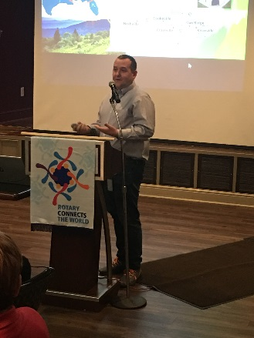

Robert gave a very informative presentation about the Mizkan Corporation especially the importance of the Crossville plant. They produce many vinegar products for major corporations especially Kroger and Walmart.

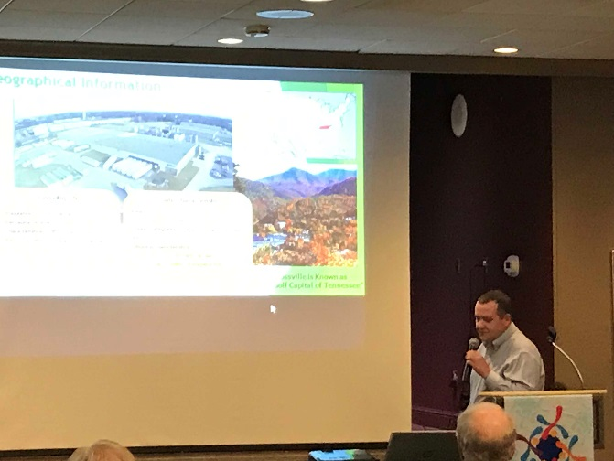

The Crossville Plant.

Rotary Grace
We break the bread which comes from you, and thank you Lord for all things true. May we, more blessed than we deserve, live less for self and more to serve.

Make ups: On the web: www.rotaryeclubone.org Crossville: Wed. 6:30 AM, Crossville Breakfast Club, Cumberland Medical Center; Thur. Noon, Crossville Noon Club, Cumberland Mountain State Park

