Rotary Club of Fairfield Glade
Club - 3856

District 6780 – James Roxlo, Governor

Box 1937, Fairfield Glade, TN 38558

www.ffgrotary.org
Facebook: Rotary Club of Fairfield Glade

Meetings
Tuesdays Legends at Druid Hills Country Club in Fairfield Glade. Lunch starting at 11:30 a.m., Meeting 12:00 p.m. to 1 p.m.
Officers
President - Tessi Gilmer
President Elect - Deb Birdsall
Vice President – Colleen Mall
Secretary - Mary Jane Ware
Treasurer - Bob Weber
Past President – Jack Williams
Sgt at Arms - Jack Baggett

Board of Directors
Officers plus
Dick Sammer- Service Programs
Chrystal Davis - Membership
Bill Collins - Foundation
Tessi Gilmer - Youth Services
Charles Lusso – Administration
Jeff Townsend – Public Relations
Future Programs

Oct 9 Dan Guerrero - Civil War Reenactment
Oct 16 R.Bruning - AVALON
Oct 23 Allen Foster - Mayor of Cumberland County

Dates to Remember
Oct 13 Alzheimers TN walk
Oct 29 5th Tuesday Halloween Party
Dec 6 Christmas Party Legends (no meeting on Tuesday Dec 4)

ROTA NEWS
October 2, 2018
Economic and Community Development Month

Today's Program
Visit to our Club by Jim Roxlo, District Governor

Last week’s meeting
Preparation for the Fairfield Glade Music Festival held Saturday, September 29

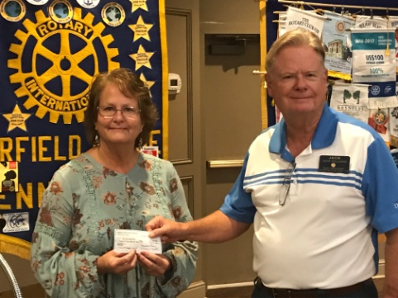
Jack Williams presenting our check to Jeanene Houston of Hilltoppers who provide services to the special needs adults in our community.

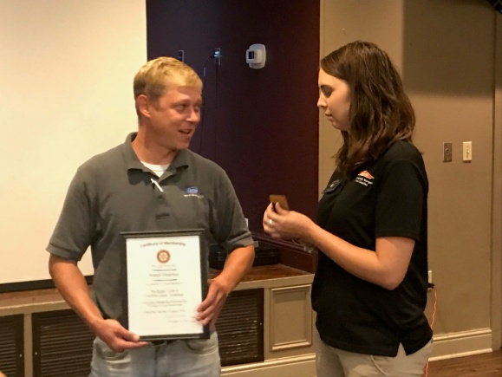
Induction of Joe Dearman by Membership Chair Crystal Davis.

RYLA (Rotary Youth Leadership Academy) was held last weekend and we sent 4 to the event.

Rotary Grace
We break the bread which comes from you, and thank you Lord for all things true. May we, more blessed than we deserve, live less for self and more to serve.

Make ups: On the web: www.rotaryeclubone.org Crossville: Wed. 6:30 AM, Crossville Breakfast Club, Cumberland Medical Center; Thur. Noon, Crossville Noon Club, Cumberland Mountain State Park

