Rotary objective is to make a difference in the World. As a Club we work to make our Community a better place to live with a focus on Youth and Elderly. We work on projects and fundraisers in order to serve our community, but we also take time enjoy fun and fellowship with fellow Rotarians. .
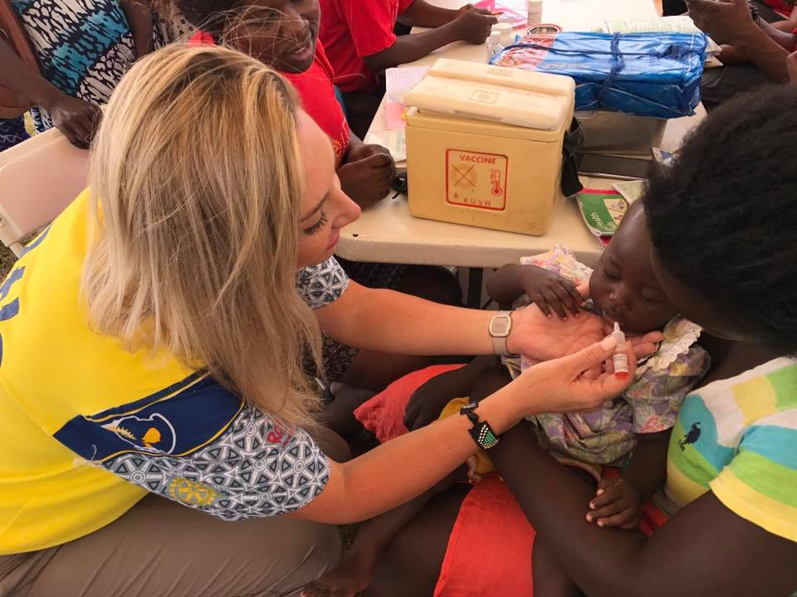 We Serve
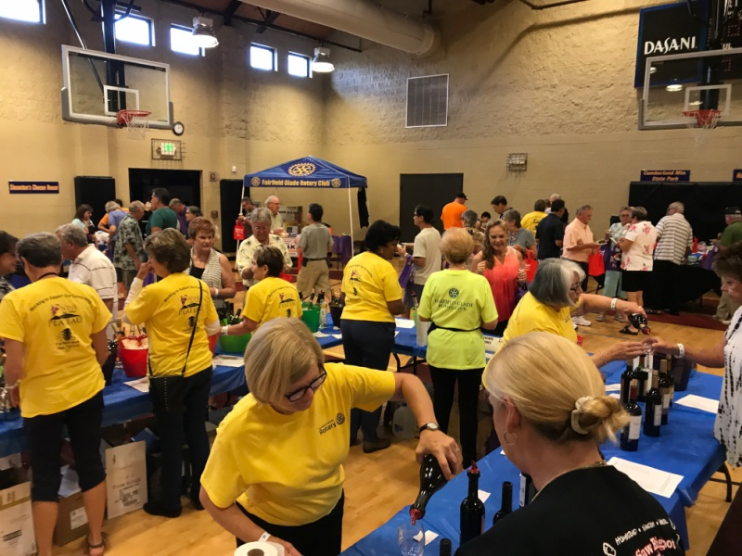 We Work
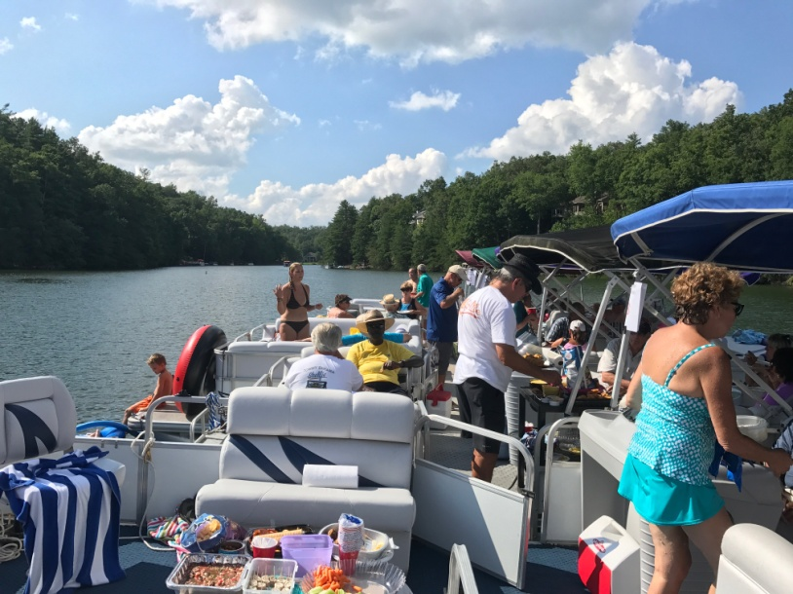 We have Fun

