FG Rotary Donates lo Youth Programs

The Fairfield Glade Rotary started off 2018 with donations to Youth Programs in Cumberland County.

Donna King, incoming President of Imagination Library of Cumberland Country, received a donation to give books to children. Imagination Library was founded by Dolly Parton and has local chapters around the country implementing her program to get books to children.

A donation to Junior League Cross Country was received by Pat Koehl and Louie DeLorenzo and this provides running shoes to those needing them so they can participate in competitive cross country running. Pat Koehl and Louie DeLorenzo are coaches implementing this program.

Donation to Donna King Donation to Louie DeLorenzo and
Imagination Library by Pat Koehl for Junior League
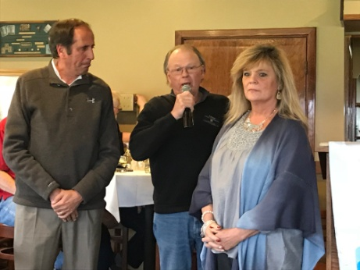
Rotarian Len Stark Cross country by Rotarian Fred Summers

