Wine On the Plateau—a great success!
An estimated 600 attendees enjoyed an afternoon of wine, beer, and food tasting at the Wine On The Plateau hosted by the Rotary Club of Fairfield Glade. The event was held in the Ballroom and Gym of the Fairfield Glade Community and Conference Center.
Much of the time participating restaurants had lines waiting for their samples. Samples were avaible from 5th Street Market, Catfish Cabin, Homestead Harvest Restaurant, Kroger, Legends, Lefty’s BBQ, Reds Ale House, Romo’s Mexican Restaurant, Scarletts Catering, Simonton Cheese House, and Stonehenge Grill.
The Rotary Club thanks the residents for their support at this event and is particularly greatful for the support of the major sponsors Crossville Heating and Cooling, Dave Kirk Automotive, Cumberland Eye Care, and Happy Hound Realty.
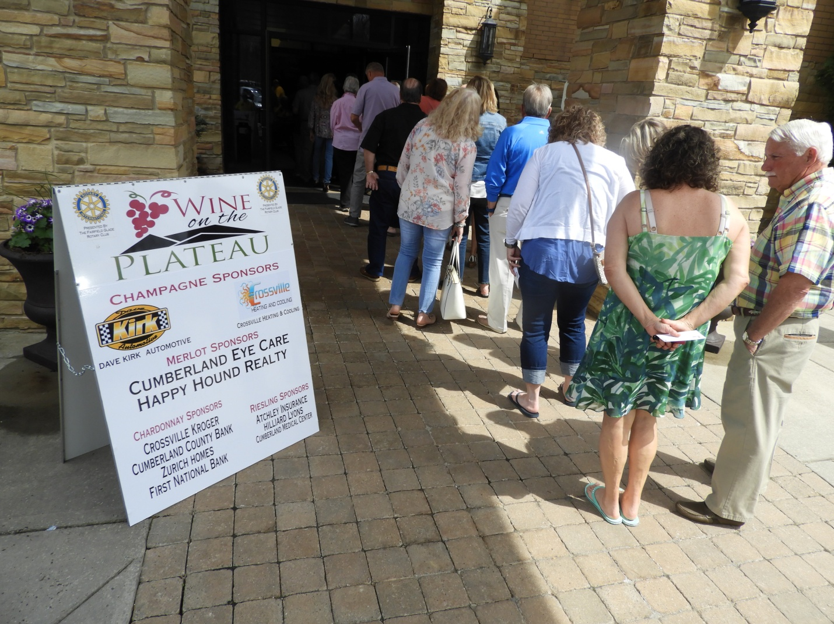
Lines still “out the door” shortly after opening at 2 p.m.
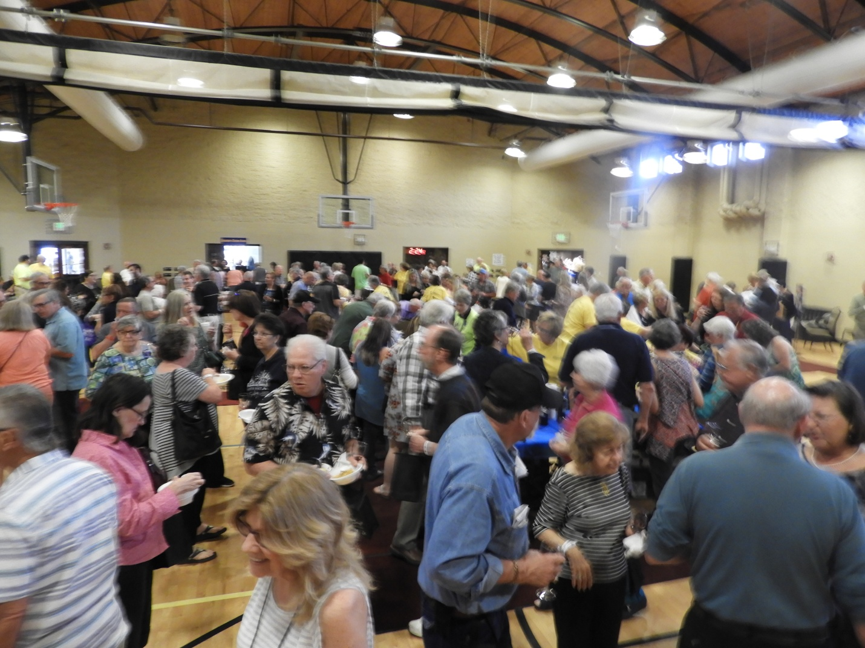
View of gym area
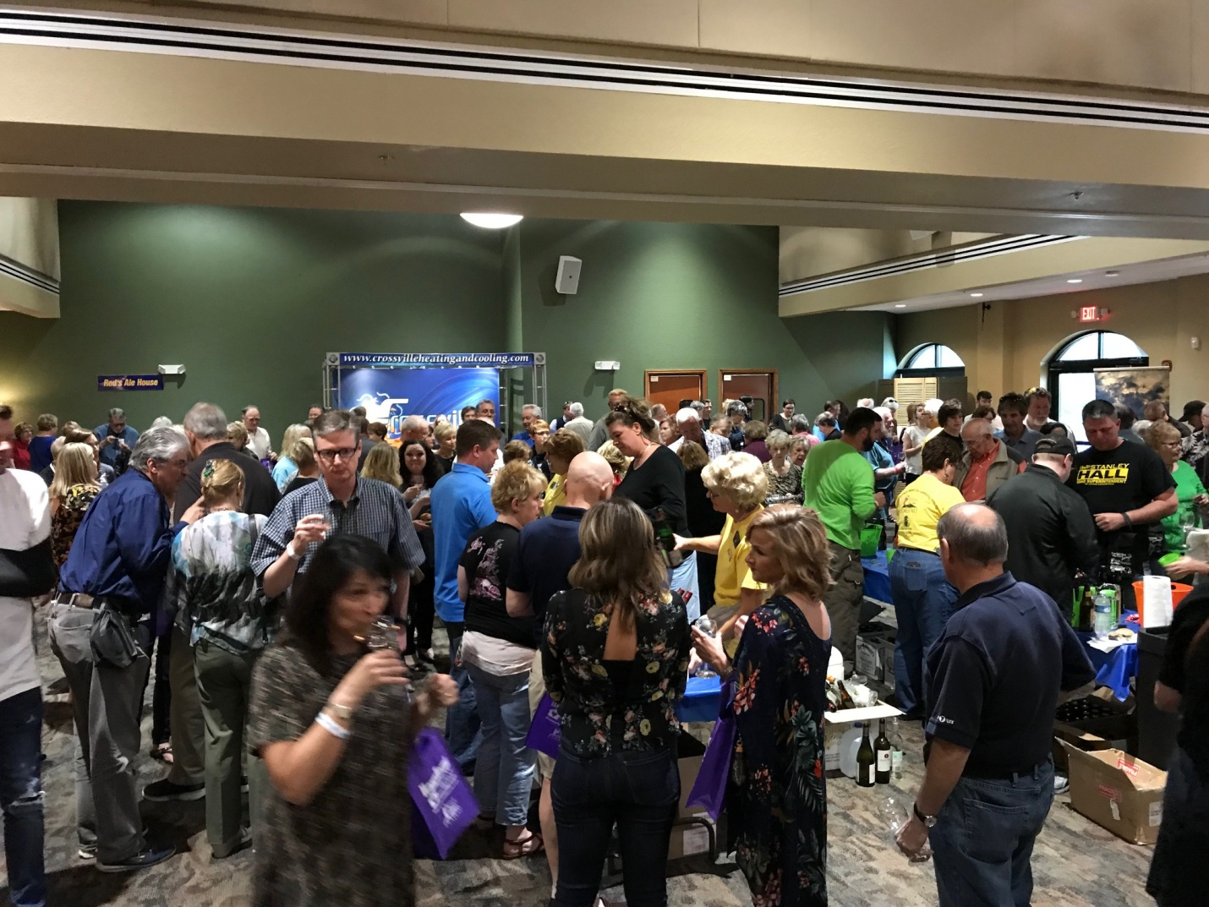
View in the Ballroom
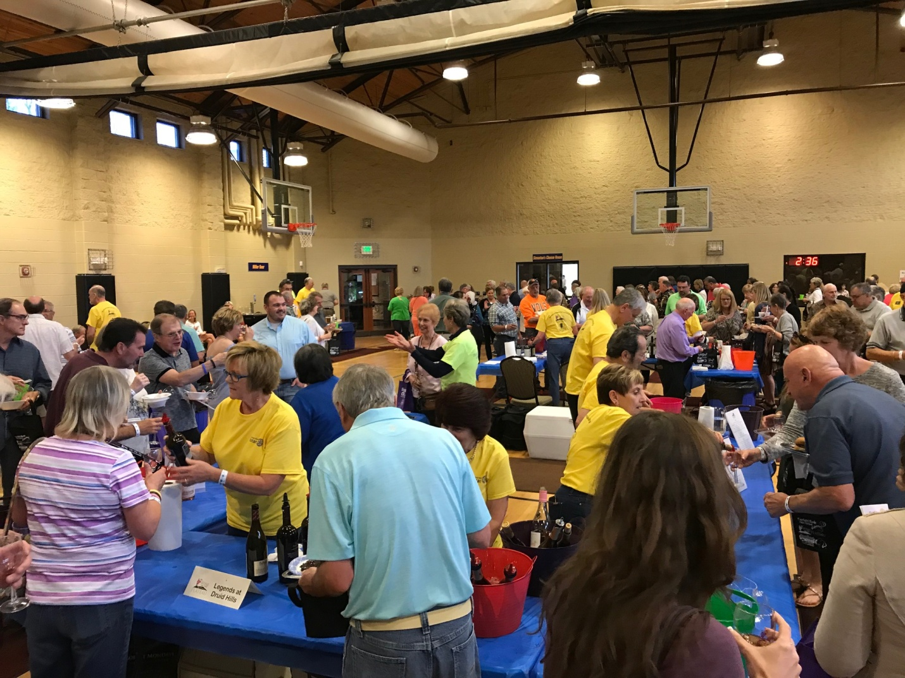
Rotarians at work serving wine tastings

