Wine on the Plateau has moved to Spring

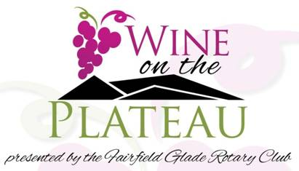

Wine on the Plateau presented by Fairfield Glade Rotary is becoming a Spring Event. We are all looking forward to Spring, but Spring weather is not very predictable. Rotary has moved the Fairfield Glade Music Festival normally held in the Spring to September.

**Wine on the Plateau** will now be on April 21, from 2 p.m. to 4 p.m., at the Community & Conference Center in Fairfield Glade. Tickets will be available in the middle of March at multiple locations and local Rotarians. Wines will be provided by Peavine Wine and Spirits Good Times Wine Spirits & Brews and our local winery, Chestnut Hill. Craft beers from Social Brew and Good Times will also be available for tasting. All of the local restaurants who participated in the last **Wine On The Plateau** are coming back again offering tasty food samples.

This is a popular event and major fund raiser for the Rotary Club of Fairfield Glade funding their donations to local charities serving our community. Sponsors allow this great event and sponsors already committed are Dave Kirk Automotive, Crossville Heating and Cooling, and Cumberland Eye Care. More sponsors are being sought. Contact Bob Weber at 931-707-2123 if you are interested in being a sponsor for this event.