Wine On The Plateau is April 27
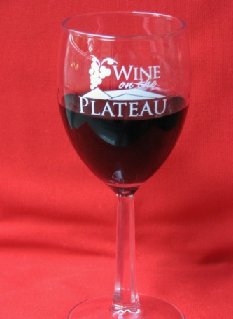
The popular, Wine On The Plateau, is coming to the Fairfield Glade Community and Conference Center on April 27 from 2-4 p.m. This Fundraising event by the Rotary Club of Fairfield Glade provides wine, beer and food tastings found in local stores and restaurants. Wines will be from California and around the world, as well as some produced locally.
This is a fun afternoon of wine, beer and food tasting that raises the funds used by the Rotary Club of Fairfield Glade to support work in our local community. Tickets will go on sale in April at only $20 each for all the wine, beer and food you can taste. The event is made possible by major sponsors Crossville Heating & Cooling and Dave Kirk Automotive. A number of local restaurants are already committed and more expected shortly. More sponsors and vendors are needed to make this a truly great event.
Mark April 27 on your calendar and those interested in being a vendor or helping to sponsor this event please contact Bob Weber at 931-707-2123 or bweber@fairfieldglade.cc.

