Wine Stuff Market raised funds for FOCCAS

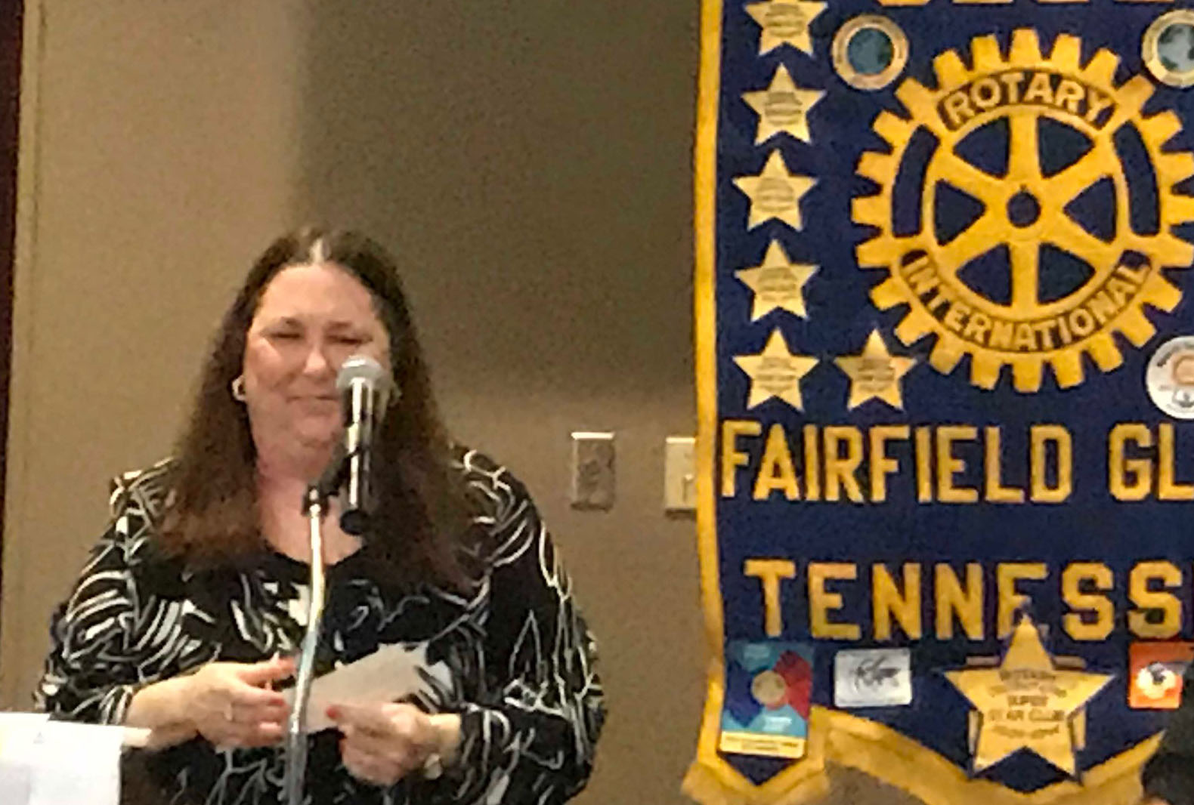
Cyd RIede of FOCCAS discussing the use of the funds just received

The Rotary Club of Fairfield Glade made a donation to the FOCCAS (Focus On Cumberland County Animal Shelter) building fund. A “Wine Stuff Market” was set up at the Music Festival last Spring and at the Wine on the Plateau last fall selling items related to serving and enjoying wine. Many items were handmade and/ or craft items but some items were clever ways to carry/display/open wines. As a new venture all proceeds from the Wine Stuff Market from these events was designated to FOCCAS as a local charity in need.
FOCCAS is a 501c3 charity committed to continuing to work towards providing for the health, safety, and enrichment of every animal at our shelter. The next, critical step is to provide funding for the construction of a new intake and quarantine/holding facility. Over $270,000 has been raised and only need an additional $60,000 to have the funds necessary to complete the facility. See http/www.foccasbuildingthedream.org/
The Rotary Club of Fairfield Glade and the Wine Stuff Market were pleased to be part of this effort and the Wine Stuff Market was a very successful new addition to these Rotary Fundraisers.

