VOAD get donation from Rotary Club of Fairfield Glade
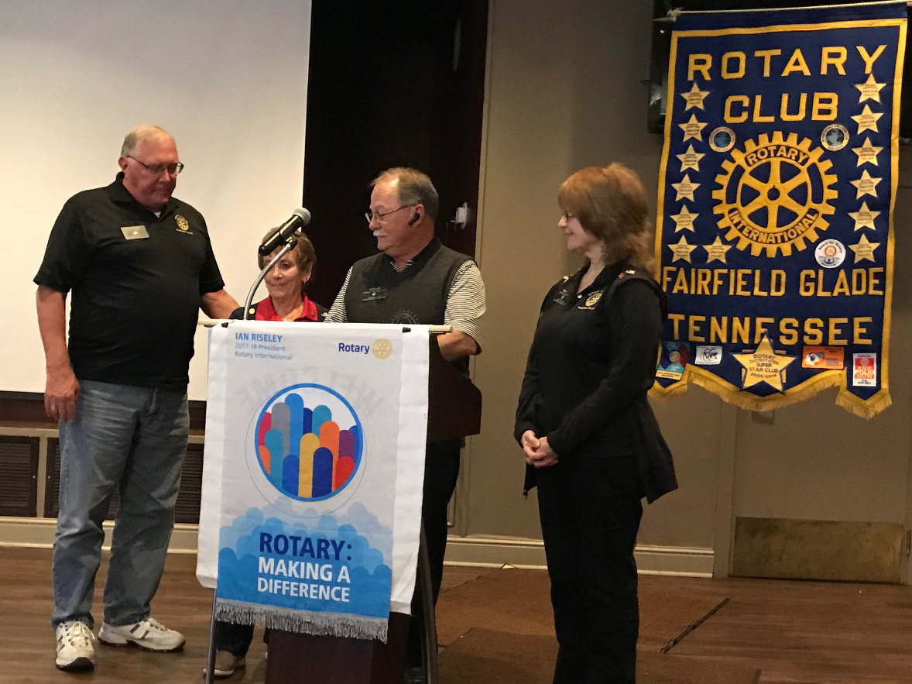
VOAD ( Volunteer Organizations Assisting in Disasters) Director Doug Scarlett (at the podium) and Volunteers Charles Lusso, and Colleen Mall show examining the check just received from Marcie Loffredo. Our local VOAD was founded by Mickey Eldridge and proved its worth in the “Great Ice Storm” by organizing the relief shelters providing meals and warm shelters for the many without power. Primary organizations in VOAD are Cumberland Good Samaritans, Red Cross, Salvation Army, and local churches. These organizations come together to help residents in the aftermath of a disaster. VOAD is planning for better responses in case of any disaster and needs funds available to use immediately after a disaster strikes.

