Tree Planting by FG Rotarians
Rotary Club of Fairfield Glade spent a morning planting trees along a stream which is a conservation area adjacent to Colinx off Genesis Rd. The President of Rotary International for 2017-18 asked Rotary Clubs to have a project to improve the environment this year. Planting trees was one of the ways to take action to improve our environment. The Fairfield Glade Club project was undertaken in cooperation with the Obed Watershed Community Association. (OWCA).
Obed Watershed Community Association (OWCA) is a Crossville, TN-based nonprofit with the mission to protect and enhance the watersheds of the Obed River and its tributaries within Cumberland County, TN through community education, creating opportunities for community research and service projects, and promoting conservation, recreation, and best management practices. It also supports activities in other nearby watersheds both within Cumberland County and surrounding counties.
Dennis Gregg, Executive Director, OWCA, lead the team of Rotarians in planting along a tributary of the Obed River. He selected the trees and plants, and provided guidance on where and how to plant the trees. He also explained the work to restore this conservation and how the area has changed since this project was started several years ago. Invasive species had taken over the area and removal is ongoing,. Many native species have been planted to replace the invasive ones and that is what the Rotarians did on their project. Since restoration began, the creek has been transformed into a meandering creek by beavers who moved into the area shortly after the conservation area was established The habitat has improved so new bird species including red-wing blackbirds and Carolina wrens have been spotted.
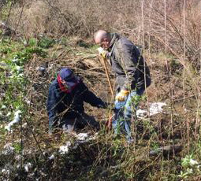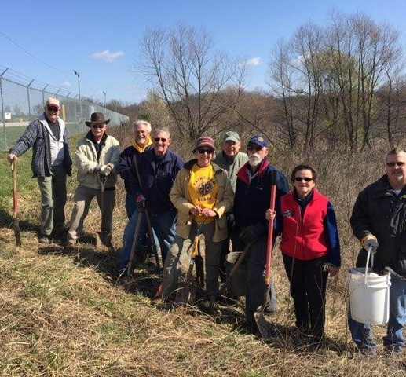
Bruce Horn and Jack Baggett planting From left, Jeff Townsend, Doug Scarlett, Dennis Hall, Doug Cooper, Mary Jane Ware, Dick Sammer, Bruce Horn, Mary Cooper, Jack Baggett

