Royal Hounds Concert to benefit school arts programs
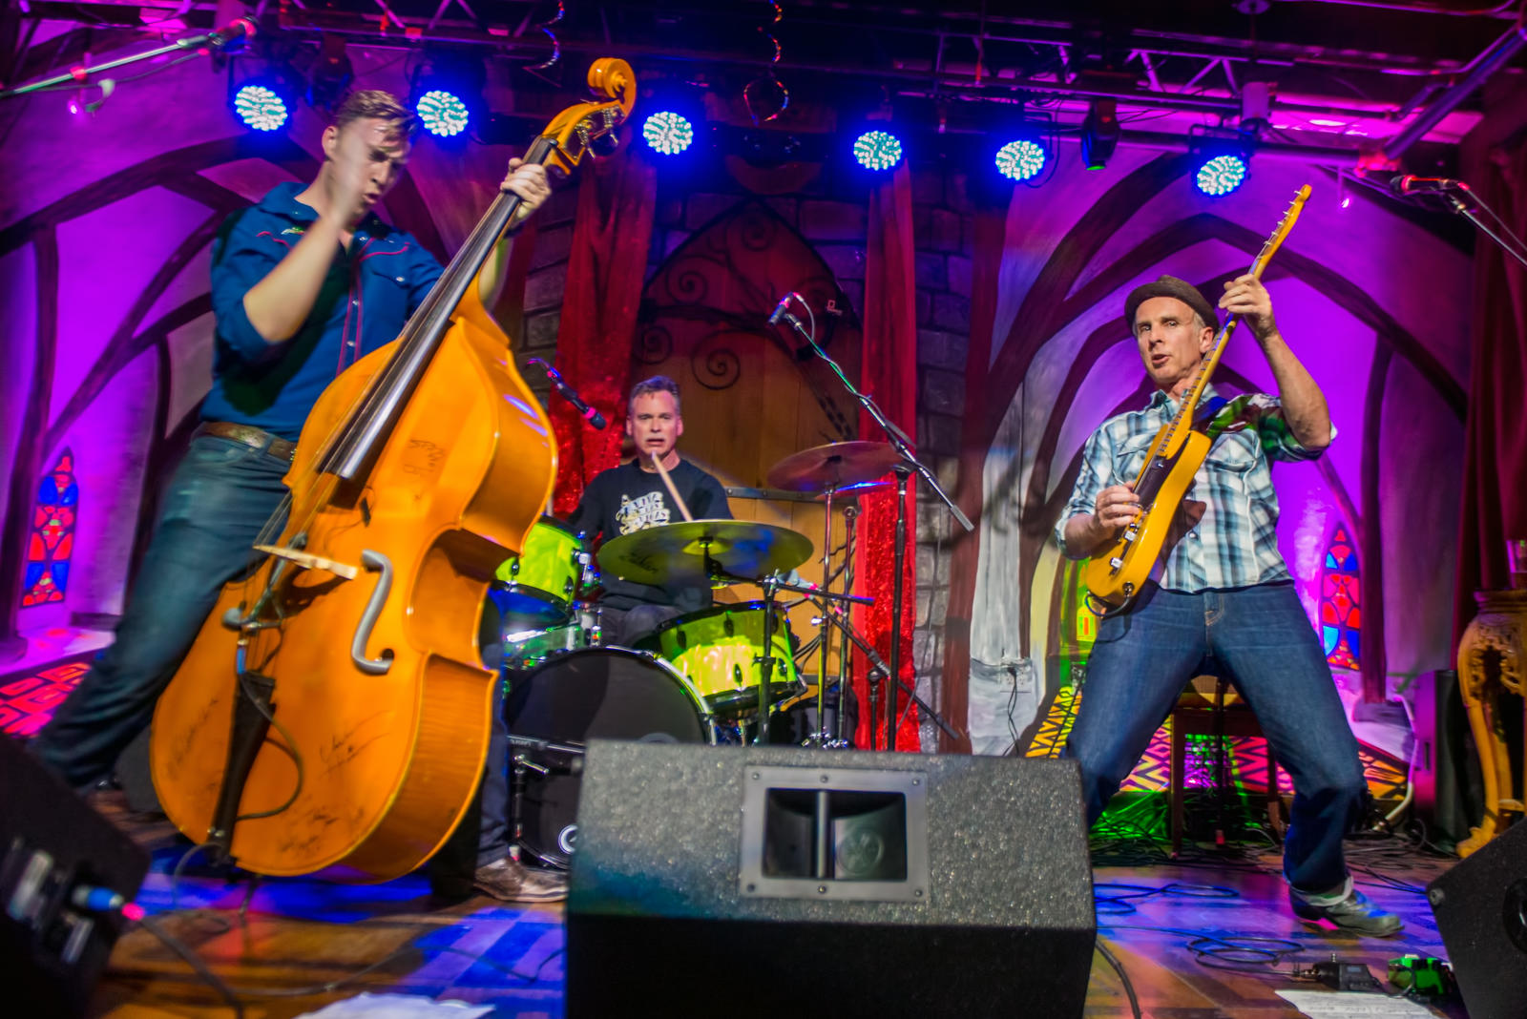
The concert, Tuesday, March 19, 7 p.m. at the Palace Theatre is sponsored by the Rotary Club of Fairfield Glade. All profits from this Royal Hounds concert will go to STARTS (Support The ARTS) in Cumberland County Schools. To maximize funds going to STARTS, Christy’s Pub & Grub (across the street from the Palace) is a sponsor for this event.
STARTS is an initiative sponsored by the Cumberland County Community Band as a 501c3 charity whose mission is to raise community awareness of and support for ARTS education programs in the Cumberland County Schools. The ARTS supported include band, chorus, classroom music, theater and visual arts. The Rotary Club of Fairfield Glade has been a partner with STARTS to bring music education to children in Cumberland County.
The Royal Hounds were a favorite at the Fairfield Glade Music Festival in September and Rotary is pleased to bring them back to play at the Palace Theatre for this benefit program. The Royal Hounds successfully marry quality musicianship with stellar showmanship. The Royal Hounds bring a unique approach to live music that includes good ol' rock and roll, country shredding, swing, honky tonk, bass surfing, instrument swapping, and on-stage antics and a quirky take on music.
Tickets are $15 and available from the Palace Theatre box office, calling (931) 484-6133 or online at
http://www.crossvilletn.gov/index.php/departments/palace-theatre

