Ringing the Bells for Salvation Army
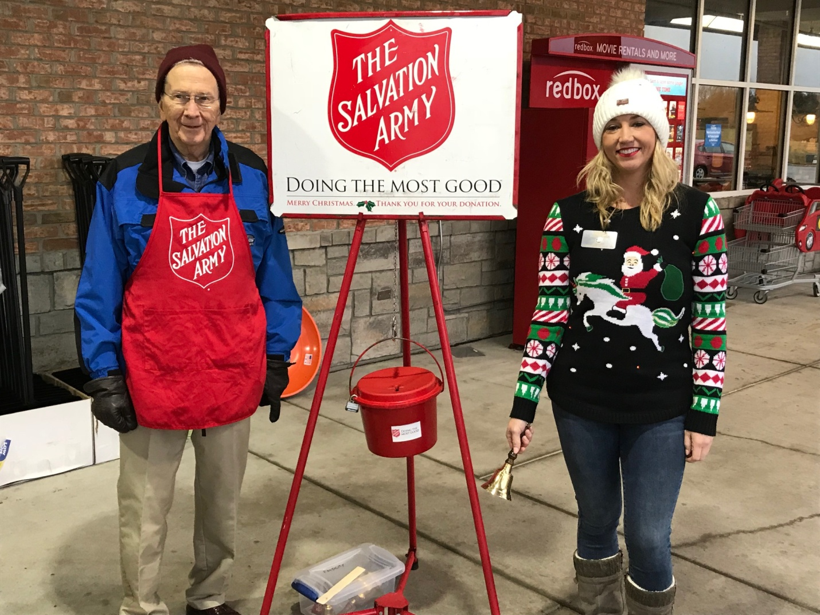
Rotarians Bill Collins and Tessi Gilmer in action at Food City

Along with other organization and groups, the Rotary Club of Fairfield Glade rang bells at the Salvation Army Kettles this Christmas Season at Food City on Peavine Road. . Some 50 Rotarians and spouses helped our community by Ringing The Bells over 2 days before Christmas..
Other organizations and groups who helped the Salvation Army in Ringing The Bells at Food City between Thanksgiving and Christmas were 39 from the Fairﬁeld Glade United Methodist Church Mens’ Club (who rang 4 days); 24 from Neighborhood Watch #081116 ; 17 from the Cumberland Shrine Club ;; and, 14 individuals from Fairfield Glade who wanted to help. Notable among individuals who volunteered to help was Rich and Cindy Leber, who rang every Friday and Saturday dressed as Mr. & Mrs. Santa Claus and were a great hit. Thanks also to everyone who contributed to the Kettles

