Music & Memory Comes of Age in Cumberland County
Frank Horvath, a Rotarian in the Rotary Club of Fairfield Glade, up-dated the Club on how much the Music & Memory Program has grown since Jack Williams brought this Project to the Club. In 2015, Jack viewed the documentary film “Alive Inside” which showed the impact hearing music from their younger years could have on patients with dementia or Alzheimer’s disease. The Club was excited about the prospect of bringing a quality of life change to those suffering various forms of dementia in our community, and established a Music & Memory Service Project under Jack’s leadership.
To begin this Service Project, the community needed to understand the concept of using Music to help those with dementia. The Rotary Club funded and advertised four (4) free showings of the Documentary “Alive Inside” –two (2) at the Palace Theater in Crossville and two (2) in Fairfield Glade. The film dramatically showed the impact that music can have on unresponsive or non-communicating patients with dementia. As expected, the public and local nursing homes were equally excited and Service Project moved forward to implementation of Music & Memory concepts in Cumberland County.
The goal of the Club with this Project was to bring the benefit of Music & Memory to dementia patients, but implementation had to be done by nursing home partners who provide patient care. The Rotary Club of Fairfield Glade established a budget to fund implementation in a few interested nursing homes. The Club also created a music library that could be used to generate play lists for each patient according the music important to that patient. The Club purchased equipment to be used and provided hands on help to nursing homes who wanted to implement personalized music for their patients.
Personal music playlists for patients in Cumberland County nursing homes began in 2016 and continued to grow in number through 2017. Fairfield Glade Resident Services, a 501c3 providing help to needy residents, became a partner to reach home bound patients in Fairfield Glade. The Rotary Chair of the Music and Memory Project transitioned from Jack Williams to Colleen Mall and then in late 2017/2018 to Frank Horvath.
In 2018 discussions began as to how to take the local Music & Memory Project to a higher level. Frank Horvath led an initiative to increase involvement of Music & Memory, Inc. a 501c3 non-profit organization based in New York. While the Music & Memory Rotary Project used the general concepts and benefited dementia patients, the Music & Memory Inc, organization ( www.musicandmemory.org ) uses a clinical approach to implementing the program for patients. This involves detailed training for implementation, documenting application, and measuring results and certifying organizations (Certified Care Organizations) to implement the program.
Frank Horvath, Rotarian, and Edward DeVries from Fairfield Glade Resident Services (FGRS) became Co-Chairs of the Project and have begun organizing multiple organizations in Cumberland County to implement the formal Music & Memory Program as group. Previously Music and Memory Inc had only worked one on one with a single organization at a time, but in Cumberland County all of the organizations wanted to work together as a collective group with Music & Memory Inc. This concept is being well received by Music & Memory Inc since they can see that it significantly extends their reach and ability to reach more patients.
Integrating personalized music into cognitively limited patient activities has been repeatedly shown through research studies to enhance engagement and socialization, heighten the patient’s ability to communicate, increase calmness and decrease agitation. This can often reduce reliance on anti-psychotic, anti-anxiety and anti-depressive medications as well as result in fewer falls, less resistance to care, and more a meaningful interaction with staff. Personalized music can produce benefits just like a prescribed medicine.
Based on the effects of personalized music being seen as being as effective treatment, Frank Horvath and Edward DeVries, with assistance of the Tennessee Music & Memory Director, developed a “Transitional Model” for implementing personalized patient music lists. This Transitional Model considers the Music & Memory personalized music lists as a prescribed treatment to be documented in patient medical records. The Transitional Model considers the music lists, equipment, and procedures just like other prescribed medicine and treatments in the medical records and follows the patient from facility to facility to be implemented for the patient the same way whether they are at home, in a nursing home, or in a hospital.
In 2018, Music and Memory Inc began In working with the State of Tennessee Department of Health and Human Services to get State funding for more implementation of Music and Memory in Tennessee. Music & Memory Inc. used this “Transitional Model” as part of their efforts to get State funding. With the help and involvement of many agencies and organization concerned for patients with dementia and/or Alzheimer’s Disease, a MILLION DOLLAR, three year grant from the Tennessee Dept or Heath and Human Services was obtained.
Launched on February 1, 2019, a grant of $1,000,000 was awarded to Music & Memory Tennessee to bring the therapeutic benefits to 147 skilled nursing homes statewide to improve clinical outcomes and quality of life through music to a minimum of 2,205 residents suffering with dementia or Alzheimer’s.
It is exciting that funds from are now available from Music & Memory Tennessee that can used to expand the local work begun in 2015 to expand benefits to patients of dementia/Alzheimer’s Disease, and that ideas and concepts developed under the Rotary Club of Fairfield Glade’s Service Project and evolved by Frank Hovath and Edward DeVries were used in this successful grant application.
Nursing homes interested in participating in this three year grant should contact Kim Johnson, Director of Arts Access for Tennessee Arts Commission who is implementing this grant at kim.johnson@tn.gov
Locally information can be obtained from Frank Horvath at fhorvath@good-sam.org or Edward DeVries at edvphd@gmail.com
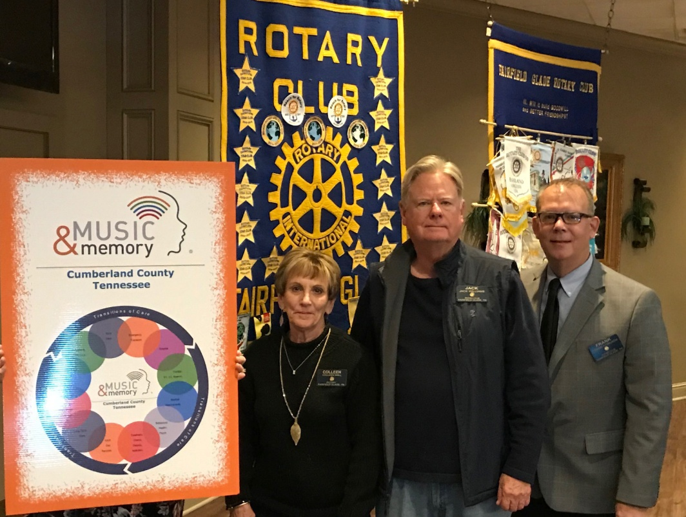
Left to right Colleen Mall, Jack Williams, Frank Horvath with a poster illustrating the Transitional Method of implementing Music & Memory for patients.

