Press Release
Rotary Club of Fairfield Glade
Jeff Townsend j1town@earthlink.net

Join the fun at Wine on the Plateau April 21
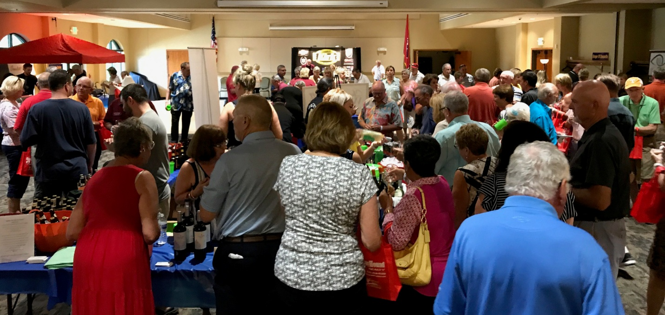
Get your tickets $20 each at Chestnut Hill Winery, Good Times Wine Spirits & Brew, Fairfield Glade Community & Conference Center, First National Bank on Peavine Rd, and Peavine Wine & Spirits as well as local Rotarians.

