FG Rotary Serves Lunch and Donates to Bread Of Life
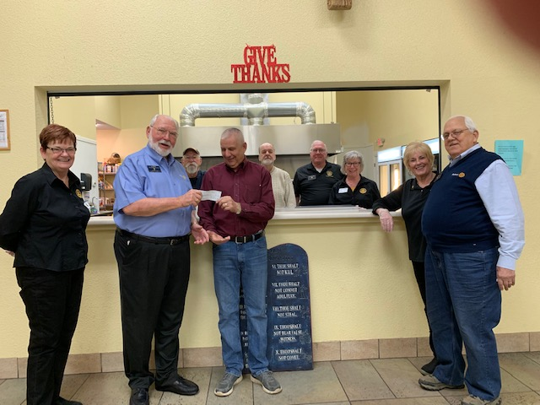
Shown left to right, Ro Kessberger, Len Stark, Rev Ralph Regan, Bread of Life, Diane Giernoth, Bill Winston in the back are Bruce Horn, John Kessberger, Charles Lusso, and Mary Jane Ware.
The Rotary Club of Fairfield Glade is pleased to support the excellent work of the Bread Of Life. the Club provided and served lunch to all at the Bread of Life Following the lunch a donation was given to Rev Ralph Regan by Rotarian Len Stark to continue the mission of the Bread Of Life to provide temporary shelter, medical attention, and food for the homeless and transient individuals and families.

