New Members Inducted into Rotary Club of Fairfield Glade

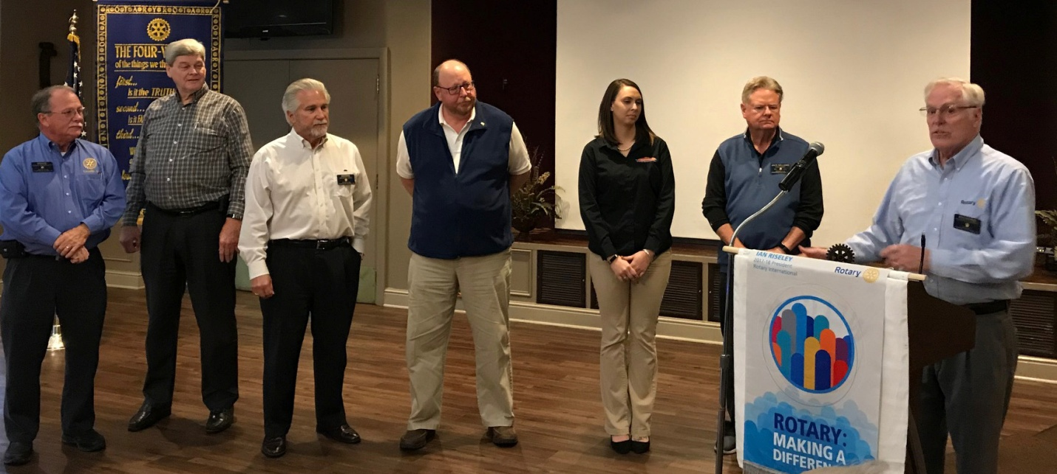
The Rotary Club of Fairfield Glade is proud to welcome 3 new members: Alan Snow, Phil McDowell, and Chrystal Davis. They were inducted February 20, 2018, by Dick Garrett. The new members and their Sponsors are shown in the picture above. From Left Doug Scarlett, Sponsor; Alan Snow; Dennis Hall, Sponsor; Phil McDowell; Chrystal Davis; Jack Williams, Sponsor; Dick Garrett Rotarian Inducting new members.
The Rotary Club of Fairfield Glade meets every Tuesday at Legends at Druid Hills at 11:30 a.m. to 1:00 p.m. Rotary Vision Statement is “Together we see a world where people unite and take action to create lasting change—across the globe, in our communities, and in ourselves”. Visitors are welcome to learn more about how to make a difference in our community and the world.

