FG Rotary Inducts 5 new members
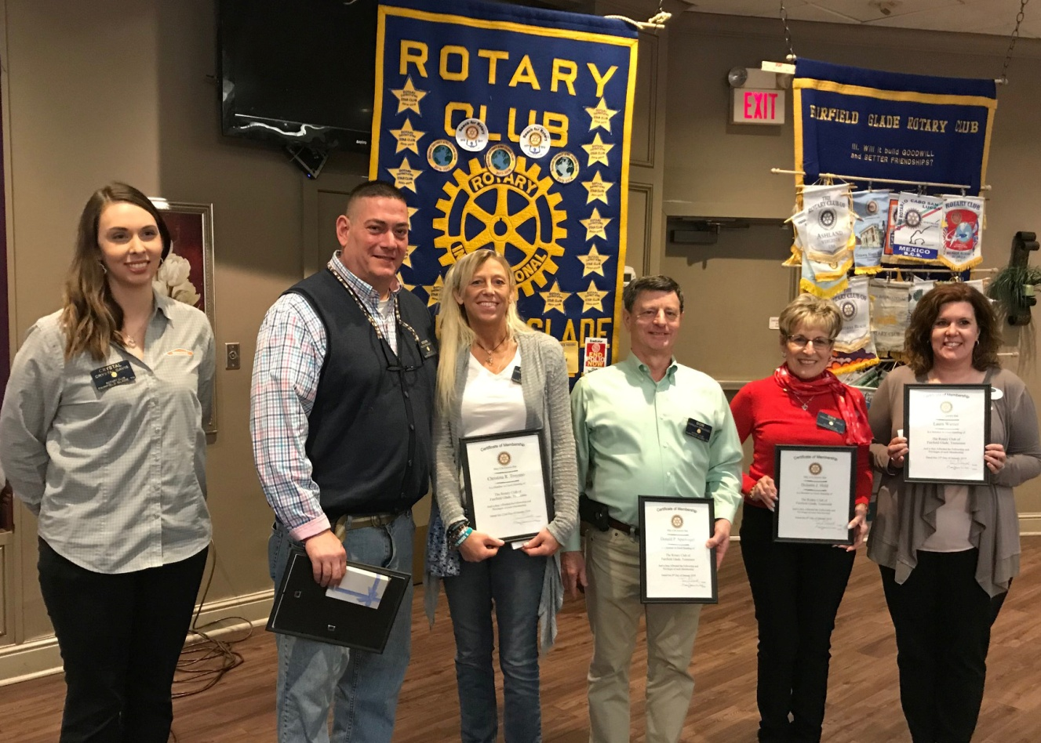
Left to right Crystal Davis, Membership Chair; new members-- Kevin Troyano, Christy Troyano, Don Spielvogel, Dolores Held, Laura Warner

The Rotary Club of Fairfield Glade was pleased to induct 5 new members on their first meeting of February. As an active Club with many projects and initiatives it is vital to grow so new projects can be undertaken to make our community better. In the last Rotary year, Club members worked on more than 6 projects to make our community better. This is addition to the two major fund raisers (Wine On The Plateau and Music Festival) which require a lot of work to raise the funds needed to fund actions and donations to make our community better.
The Rotary Club of Fairfield Glade meets every Tuesday at Legends at Druid Hills—lunch at 11:30 a.m. and meeting from 12 noon to 1 p.m.. If you are interested in “giving back” to our community, please visit to see how you can contribute.

