FG Rotary Donations Benefit Students
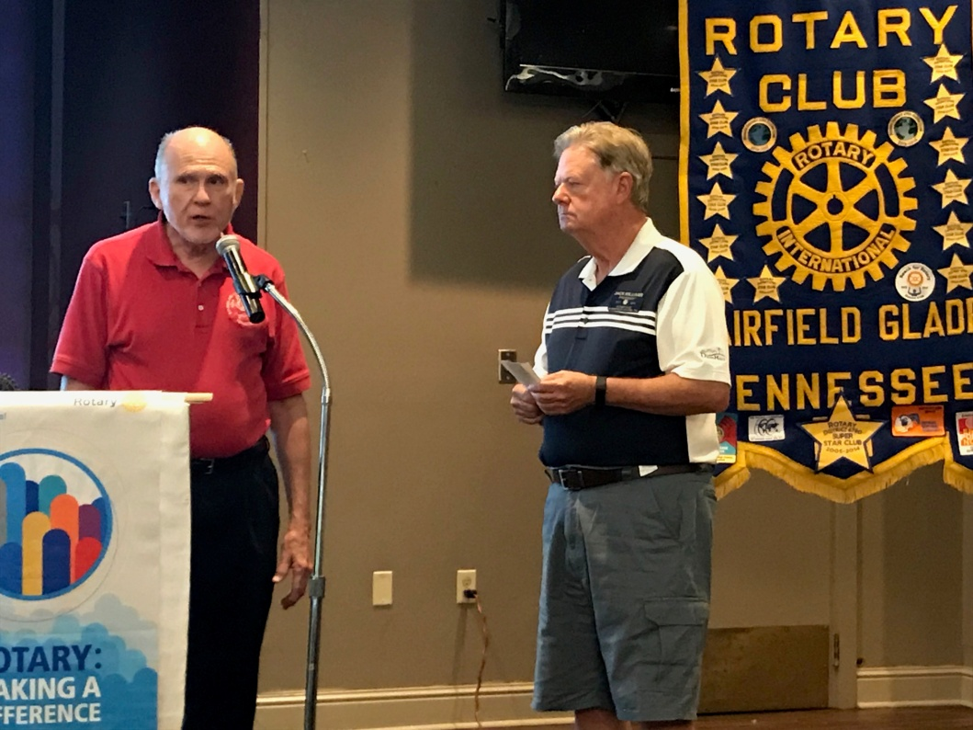
Glenn Belcher receives a check on behalf of STARTS (Supporting the ARTS) from Jack Williams, President of the Rotary Club of Fairfield Glade. STARTS (Support the Arts) is a 501c(3) not for profit organization that was established to increase the awareness and support for the fine arts (music, visual arts, theater, chorus, drama, dance, etc.) in the Cumberland County Schools. Data shows that study and participation in the fine arts is a key component in improving learning throughout all academic areas.
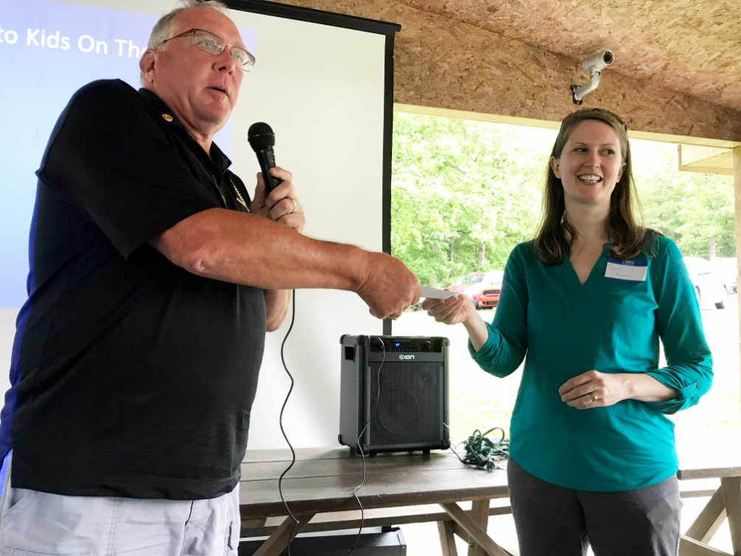
FG Rotarian and Kids on the Rise Board member, Charles Lusso, is shown presenting the Rotary donation of Pam Burris from Kids on The Rise. Kids On The Rise provides meaningful experiences that help build a one-on-one relationship between a caring adult and a youth who may be experiencing difficult day-to-day life challenges. Mentors provide academic support, strong role models, encouragement, and compassion to each child we serve so they can succeed in school and in life.

