FG Rotary Donates to Junior Achievement
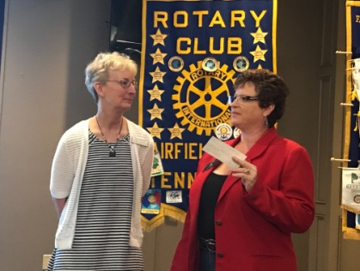

Holly Hanson is about to receive the Rotary Club of Fairfield Glade donation from Deb Birdsall. Rotary is pleased to keep supporting youth programs such Junior Achievement whose mission is to enhance the economic development of our community by supporting programs and activities that inspire young people to succeed in the global economy. About 600 local students go to BizTown-- a fully-interaction simulated town which provides 4-6th graders experiential learning to develop an understanding of the relationship between what they learn in school and their successful participation in our global economy.

