Fairfield Glade Rotary Donates to Honor Air

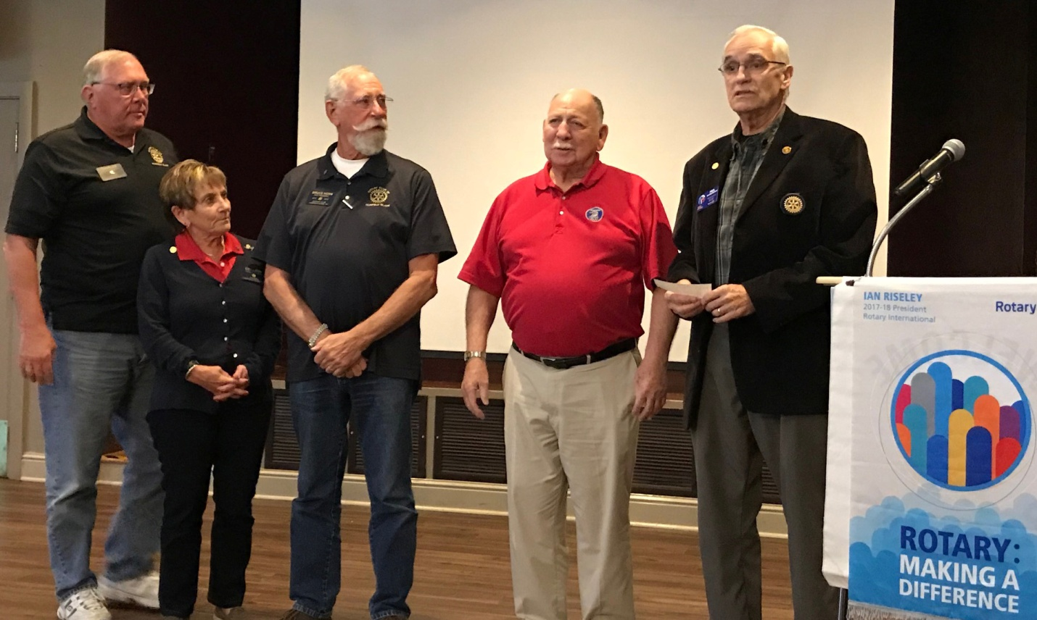

Rotary Club of Fairfield Glade donation to Honor Air Knoxville is received by Gus Gocella. Honor Air Knoxville takes Veterans to Washington DC to visit war memorials. The next Flight, number 25, is April 11 and includes about a dozen veterans from Cumberland County. Honor Air takes veterans at no cost and Veterans have escort to help them enjoy the experience. Escorts pay their own way. The check is being presented by Rotarians who have been escorts on Honor Air Flights. Visit [www.honorairknoxville.com](http://www.honorairknoxville.com) to donate, apply to take a flight, be an escort, or learn more. Shown left to right are Charles Lussco, Colleen Mall, Bruce Horn, Gus Gocella, Paul Wennermark.