Rotary Donates to Bread of Life

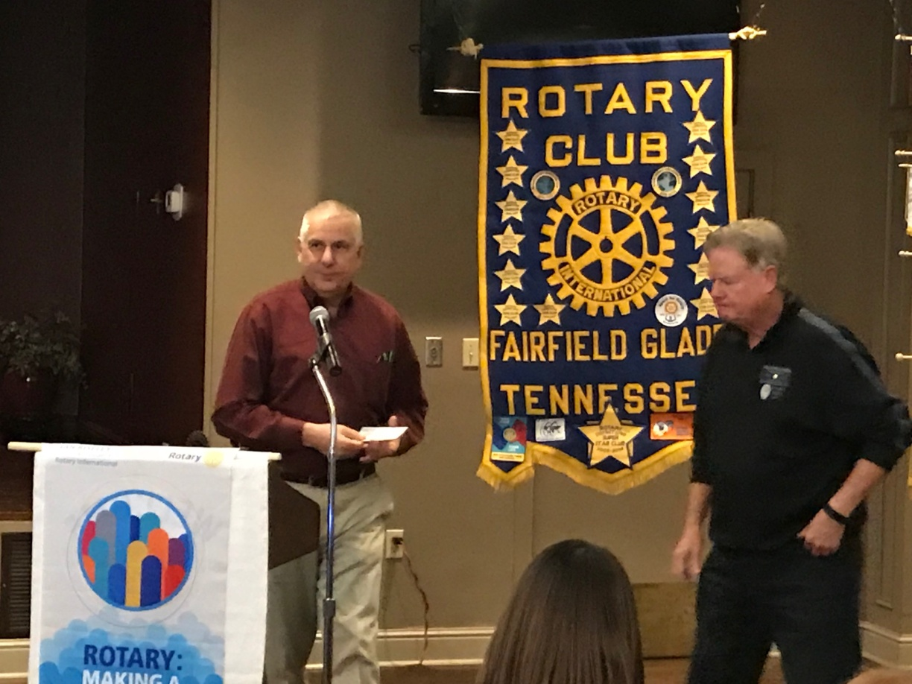
Rev. Ralph Reagan of Bread of Life with donation just received from Rotary Club of Fairfield Glade President, Jack Williams. The Club has been a regular supporter of the work of the Bread of Life Rescue Mission of feeding, housing, helping, and guiding people in need in our Cumberland community.

