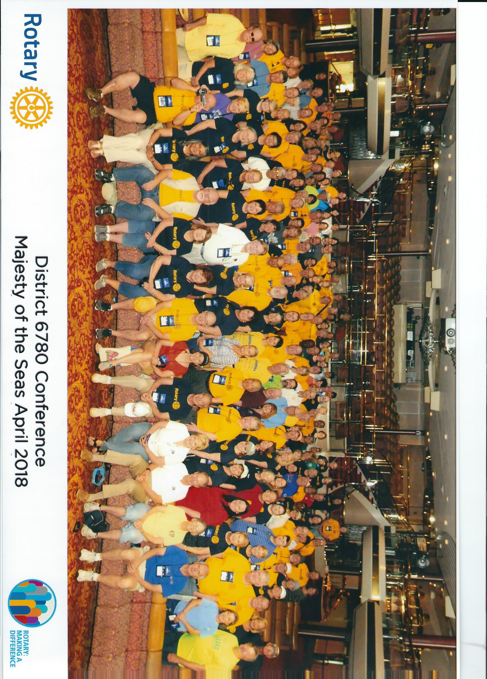
FG Rotary attends the District 6780 District Conference Cruise

Fourteen Rotarians from the Fairfield Glade Club attended the first ever District 6780 Conference Cruise. Usually District Conferences are held at hotels in the area with recent ones being in Pigeon Forge and Chattanooga, This year it was held on a Cruise Ship. The ship, “Majesty of the Seas” sailed out of Port Canaveral, Fl for a 3 night cruise to Nassau, Bahamas. They joined over 200 other Rotarians from the District representing 42 of the 64 of the Clubs in the District. The Rotary Club of Crossville was also represented at Cruise Conference.
Initial meetings and presentations were held shortly after departure from port followed by social hour and dinner. The next morning business meetings and presentations were held in the morning, but then attendees departed ship to work on 10 service projects in Nassau in conjunction with 8 local Nassau Rotary Clubs as part of a Service Day honoring the President Elect of Rotary International, Barry Rassin, who is from the Bahamas. Performing these service projects in Nassau was a key focus of the trip and some $16,000 in funds were dedicated to projects as well as about 500 hours of service work performed.
The projects ranged from painting (Salvation Army Building & School Library), to construction (library shelves & neighborhood library boxes & school lunch benches) to providing career guidance to high school seniors and reading to children in the hospital to helping to restore a Mangrove area of a State Park with clean-up and planting of new trees. A remote Island school received backpacks of school supplies and elderly in a home for the aged on the island received hygiene kits. More than 400 books, brought by the Rotarians attending the conference, were donated to school libraries.
The next day was a chance to enjoy the beaches and activities of CoccoCay, a private island of Royal Caribbean, followed by final presentations of Awards as the ship steamed back to Port Canaveral. Evenings gave time for socializing and enjoying the many activities available on board the ship. A favorite each night was a piano bar with dancing. The Fairfield Glade Club was recognized for having the most in attendance and was proud to be one of the top Clubs in the District in number of Awards received for their Rotary work this year..

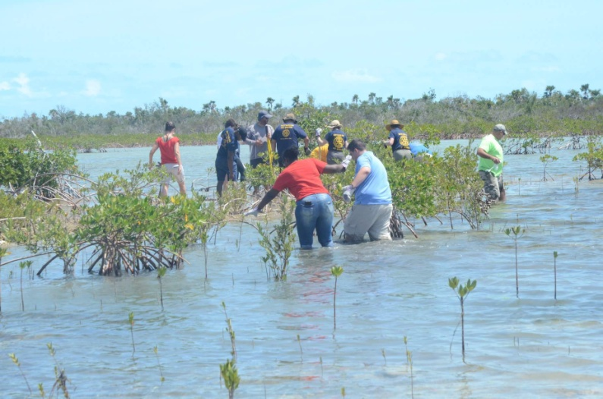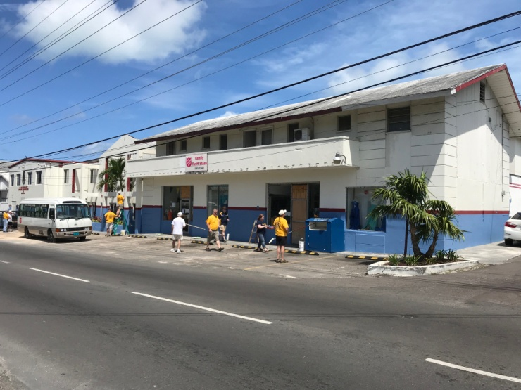
Mangrove work Painting Salvation Army Building Nassau

